**Registration Form**

**TO** **Email** :

The Incharge ramanan@westernthomsonindia.com/ sgopi@svce.ac.in

Quality Management Centre Mobile: 9962055229 / 9445115107

Dept. of Mechanical Engineering

SVCE

**GD and T COURSE**

3 Day Work Shop

(Saturdays & Sundays)

Presented By

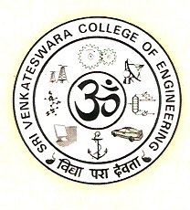

**QUALITY MANAGEMENT CENTRE**

**Department of Mechanical Engineering**

**Sri Venkateswara College of Engineering (SVCE)**

**In Association with**

**CTRI**

**CT Research Institute**

**Research and Training wing of Western Thomson India Ltd. (WTI)**

We would like to nominate the following for the above course.

**Name of Organization :**

|  |  |  |  |  |  |
| --- | --- | --- | --- | --- | --- |
| Sl.No | Name | Department | Designation | Mobile No. | Email ID |
| 1 |  |  |  |  |  |
| 2 |  |  |  |  |  |
| 3 |  |  |  |  |  |
| 4 |  |  |  |  |  |

**COURSE FEE**

* 10% Discount for 3 or more registrations from same organization
* Cheque/Cash favoring “The Principal, Sri Venkateswara college of engineering’”

**DATE SIGNATURE**