Registration Form
TO Email :
The Incharge ramanan@westernthomsonindia.com/ sgopi@svce.ac.in
Quality Management Centre Mobile: 9962055229 / 9445115107
Dept. of Mechanical Engineering
SVCE
TPM COURSE

2 Day Work Shop

(Saturdays & Sundays)
Presented By

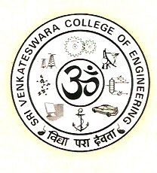

QUALITY MANAGEMENT CENTRE
Department of Mechanical Engineering
Sri Venkateswara College of Engineering (SVCE)
In Association with
CTRI
CT Research Institute
Research and Training wing of Western Thomson India Ltd. (WTI)

Name of Organization :
Sl.No | Name | Department | Mobile No. | Email ID
1
2
3
4
COURSE FEE
- 10% Discount for 3 or more registrations from same organization
- Cheque/Cash favoring “The Principal, Sri Venkateswara college of engineering’”

DATE SIGNATURE

