Dr. T. Balusamy Assistant Professor Department of Applied Chemistry email:rtbalu@svce.ac.in Phone: 91 44 2715 2000 Ext 858
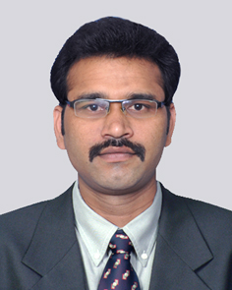

Postdoctoral Research Fellow, National Institute for Materials Science (NIMS), Japan
June 2014–May 2016
Ph.D., Chemistry – University of Madras, Chennai, India Feb 2009- April 2014
M.Sc. Chemistry - Bharathiar University, Coimbatore, India May 2008
Teaching & Research Experience: 1 year
Research interest

- Nano Science and Nano Technology
- Electrochemistry
- Surface science and engineering
- Bio-materials
- Coatings

