Dr.S.Premnath Assistant Professor Department of Automobile Engineering mail:prem@svce.ac.in; Phone: 044-27152000 Ext. 454 Mobile : 9841693964

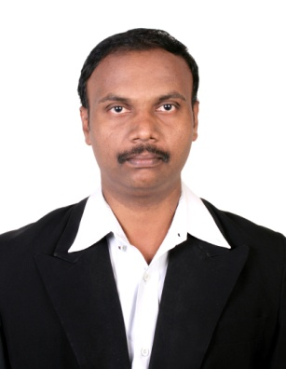

Ph. D
Title : Optimization of Combustion chamber for Improving the Performance and reducing the emissions of Jatropha Methyl esters

Year : 2017
University : Anna University, Chennai (M.I.T Campus)
M.E.
Specialization: Automobile Engineering
Year : 2004
University : Anna University, Chennai (M.I.T Campus)

Research interest

- I.C. Engines
- Emission Control
- Bio fuel
- Optimization Techniques

