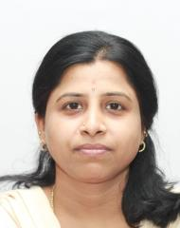 | Dr. N. Rajeswari,  Associate Professor  Department of Computer Science and Engineering  Sri Venkateswara College of Engineering  Pennalur, Sriperumbudur – 602117

Degree | Specialization | University | Year of Completion
B.Sc | Computer Science | University of Madras | May 1999
M.Sc | Computer Science | Periyar University, Salem | May2001
M.E. | Computer Science and Engineering | Sri Venkateswara College of Engineering  Anna University | June 2008
Ph.D. | Information and Communication Engineering | Anna University | February 2019

Research
Recognized as a Research Supervisor by Anna University for guiding Ph.D. scholars (Supervisor No- 3540015)

Research Areas
- Pattern Classification
- Machine Learning
- Deep Learning
- Speech and Vision

