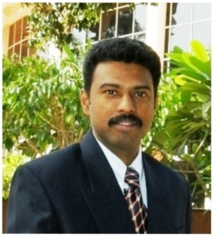
Dr. M. ANANTH KUMAR
Associate Professor in Mechanical Engineering email:ananthkumar@svce.ac.in
Phone: +91 44 2715 2000 Ext. 401
Mobile No.: +91 8807331606

Ph.D: Okayama University, Okayama, Japan.
M.E.: Institute of Chemical Technology, University of Mumbai, Mumbai.
B.E.: Government College of Engineering, Tirunelveli.
Teaching & Research Experience: 17 years
Anna University Supervisor Reference No.: 2620012

Research Interests

Surface Engineering & Tribology: Surface modifications by Electroless Coatings, Diamond-Like Carbon Coatings, Thin-Film Coatings, and Thermal Spraying. Tribological characteristics of Abrasive, Erosive, Cavitation, Adhesive, Corrosive, Oxidative, Fatigue, and Fretting Wear.
Materials Engineering: Metal Matrix Composite Materials, Strengthening Mechanisms, Structure-Property Correlation, Mechanical property evaluation, Fracture Mechanics. Polymer Composites, Natural and Synthetic Fiber Reinforcements, Fiber & Particle Reinforcements, Polymer Nanocomposite, Polymer Blends Rheological Studies, Mechanical property evaluation.

