Dr. A.R. Vijayalakshmi
Assistant professor
Email : avijaya@svce.ac.in
Phone:91 44 2715000 Ext 159

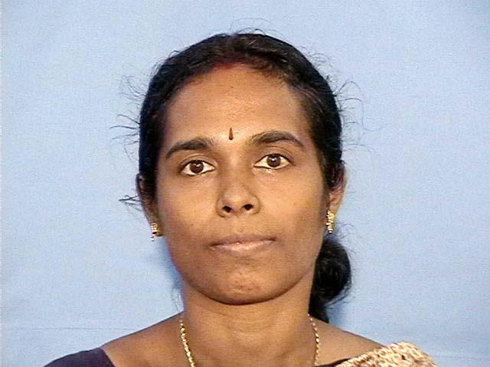

Ph D Allagappa University, Computational fluid
Karaikudi ,India dynamics , Jan.2008

MPhil Ramanujan Intitute for Mathematics Sep.1989
Madras University

MSc The KonguNdu Arts & Science May 1988
Bharathiar University,Coimbatore

BSc P.S.G.R.Krishnammal college for women Apr.1986
Bharathiar University,Coimbatore

Teaching Experience : 18 years

Research Experience: 8 years

Computational fluid dynamics: Heat & mass transfer problems are analyzed in both theoretical and computational fluid dynamics .

