Dr. C. JAYAKUMAR Head and Professor of Computer Science and Engineering email: cjayakumar@svce.ac.in Ph: 044-27152000 Ext:300

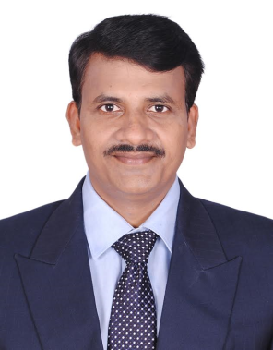

EDUCATIONAL QUALIFICATION
- Ph.D. in Computer Science and Engineering, October 2006, College of Engineering Guindy, Anna University Chennai.
Ph.D. thesis title "Design of Routing Protocols for Mobile AdhocNetwork".

- M.E in Computer Science and Engineering, January 2001College of Engineering Guindy, Anna University Chennai

- B.E in Electrical and Electronics Engineering April 1997 , Noorul Islam College of Engineering Manonmaniam Sundaranar University, Tirunelveli

Teaching & Research Experience : 17 years 7 months
Supervisor Ref No. : 8740113
University : Anna University, Chennai-25
Research interest
- Mobile adhoc Network
- Pervasive computing
- Wireless sensor Networks

