Dr. C.Yaashuwanth Associate Professor of Information Technology email:yaashuwanth@svce.ac.in; Phone: 91 44 2715 2000 Ext. 351

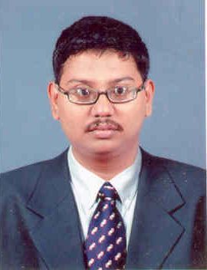

PhD Anna University Chennai Electrical Engineering
December 2012
M.E Anna University Chennai Embedded System Technologies
June 2009
BTech Anna University Chennai Information Technology
June 2007
Teaching & Research Experience: 4 years

Research interest

Microcontroller based application Microcontroller based electrical applications and wireless sensor Network
Real Tome Operating Systems Real time operating systems with embedded applications

