Dr. S. Ganesh Vaidyanathan
Professor & Principal
Department of Electronics & Communication Engg.
Sri Venkateswara College of Engineering
An Autonomous Institution - Affiliated to Anna University
E-mail:gvaidyas@svce.ac.in;
Mobile :+91-9445694664
Phone:+91-44-27152000-Ext. 103
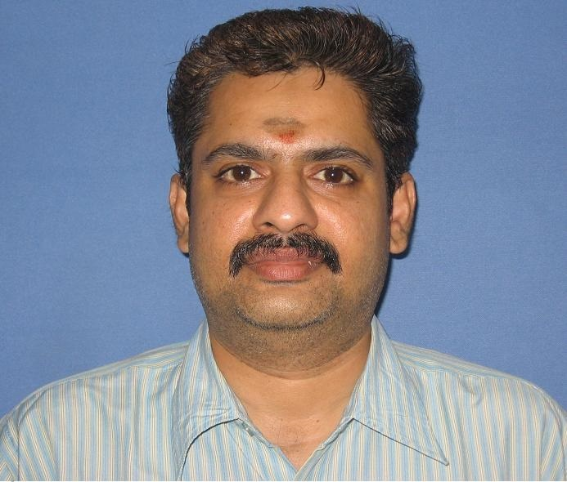

Ph. D Anna University Information and Communication
MS BITS - Pilani Electronics and Control
ME MIT-Anna University Mechatronics
BE SVCE Electronics and Communication Engineering

Teaching & Research Experience: 22 Years
Area of Interest: Image Processing, Pattern Recognition and Soft Computing
AU Recognized Supervisor Number: 2540007

