Dr G Baskar Assistant Professor Department of Applied Chemistry email:gbaskar@svce.ac.in Phone: 91 44 2715 2000 Ext. 169
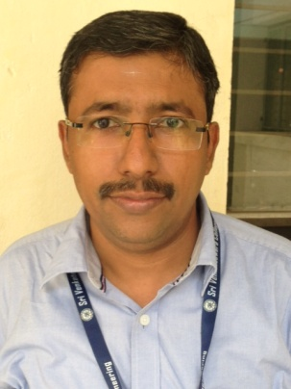

PhD Annamalai University, June 2002 Organic synthesis
MPhil Annamalai University, July 1998 Organic synthesis
MSc Annamalai University, June 1996 Organic chemistry
BSc St. Joseph’s College, Trichy, June 1994 Chemistry
Teaching & Research Experience: 14 years
Research interest

Organic synthesis: Synthesis of piperidones and azabicyclo compounds; Conformational analysis of heterocyclic compounds. Preparation of derivatives of thiopyrans, piperidones and their anti-microbial studies.

