Dr. J. M. Gnanasekar Professor of Computer Science and Enginering email: jmg@svce.ac.in Phone: 91 44 2715 2000 Ext. 304, 9444508360

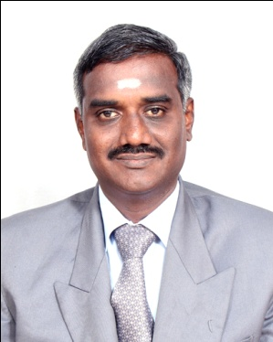

EDUCATIONAL QUALIFICATION
Ph. D. | CEG, Anna University, Chennai | Computer Science & Engineering (2010)
M.E | CEG, Anna University, Chennai | Computer Science & Engineering (2001)
B.E | PSNA College of Engg. & Tech.  Madurai Kamaraj University | Electronics & Communication Engineering (1993)

Title of Ph.D. Thesis : Enhanced Multi-Agents Based Model for
Convergent Business Services
Teaching & Research Experience : 20 years
Supervisor Ref No. : 2740133
University : Anna University, Chennai-25
Research interest

- Cloud Computing : Security & Resource Provisioning
- Bigdata : Data Analytics & Data Visualization
- Natural language Processing

