Dr. Sumathi Ganesan Professor of Information Technology email: gsumathi@svce.ac.in Phone: 91 44 2715 2000 Ext. 190
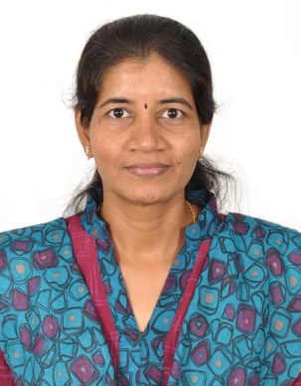

PhD National Institute of Technology, Tiruchirappalli Grid Computing
Tamil Nadu, India. March 2004
MENational Institute of Technology, Tiruchirappalli Computer Science & Engg
Tamil Nadu, India. Dec 1994

Teaching & Research Experience: 22 years
Research interest

Parallel and Distributed Computing: Cluster, Peer to Peer, Grid and Cloud Computing; Storage Systems; Parallel Programming Systems and Models
Computer Networks: Computer Communication Networks; High Speed Networks

