Dr. P.Jothilakshmi Professor of Electronics and Communication Engineering email:jothi@svce.ac.in; Phone: 91 44 2715 2000 Ext. 201
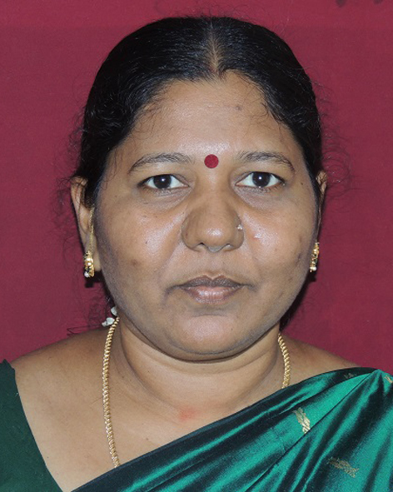

PhD Anna University Chennai Information and Communication Engineering
August 2015
M.E Madurai Kamaraj University, Madurai Communication Systems
December 2000
B.E Madras University, Chennai Electronics and Communication Engineering
April1996
Teaching & Research Experience: 15.4 years
Industry : 3.1 Years
Total Experience : 18.5 Years
AU Recognized Supervisor : 2740016
Number of Ph.D Scholars : 3 (2PT+1FT)
Research Publications : Published 67 papers in reputed National and
International Journals and Conferences(Annexure I & Annexure II –unpaid).

Research interest

Multiband Antenna design Designand development of multiband antennas for various wireless communication applications.
Microwave Development and analysis of microwave antennas forvarious applications.
Wireless CommunicationDevelopment of algorithms and analyzing various parameters for a wireless communication network.
RF MEMS Design and Analysis of RF MEMs Technology.

