Dr. Venkatesan. J Professor & Head - Automobile Engineering email: jvenkat@svce.ac.in; hodae@svce.ac.in Phone: 91 44 2715 2000 Ext. 450
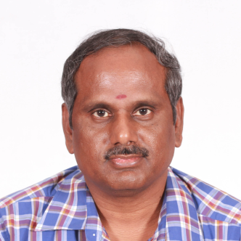

Ph. D
Title : Modelling and Experimental Analysis of Automotive Reciprocating
Air Compressor
Year : 2011
University : Anna University, Chennai
M.E.
Specilisation: Thermal Power Equipment
Year : Dec 1995
University : NIT Trichy, Bharathidasan University
Teaching & Research Experience: 20 years
Research Interest
- Heat Transfer & Heat Exchangers
- I.C. Engines
- Automotive Air Conditioning
- Modelling of Thermal Equipment

