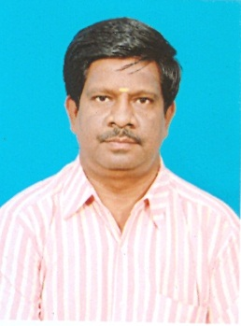
Dr.K.Pitchandi,

Professor and Head
Department of Mechanical Engineering
Sri Venkateswara College of Engineering,
Post bag #1, Pennalur, Irunkattukottai (P.O)
Sriperumbudur Taluk – 602 117, Tamilnadu.
Phone: 044 – 27152000; Ext: 400
Mobile: 94452 18415; 81488 17595
Email : pitch@svce.ac.in ; hodme@svce.ac.in

EDUCATIONAL QUALIFICATIONS

S. No | Degree | Institution/University | Field of study
1 | B.E., | Government college of Engineering, Salem. Madras University. (1993) | Mechanical Engineering
2 | M.E., | Regional Engineering college (NIT), Trichirappalli.  Bharathidasan University (1994) | Design and production of thermal power equipment
3 | PhD | College of Engineering, Guindy Anna university (2009) | Thermodynamic Optimization of Heat Exchangers

FIELD OF INTEREST

- Optimization of Thermal system
- Heat Exchanger
- Heat transfer in Micro channels
- Design of Boilers
- Design of Gasifiers.
- Thermodynamic analysis of Heat Transfer Equipments.
- Fluid Flow in cyclone Heat exchangers.
- Renewable sources of energy, Particularly Bio fuel.

