Prof. Muthukumaran Sivanandham Director- Research & Professor of Biotechnology email:drresearch@svce.ac.in; msiva@svce.ac.in Phone: 91 44 2715 2000 Ext. 577

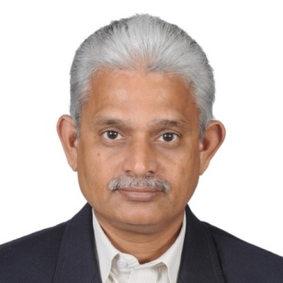

PhD University of Madras, Immunotechnology
Cancer Institute, Madras, India July 1987
MSc University of Madras, India. Biochemistry (Fermentation Technology)
July 1980
PDF University of Connecticut Cellular Immunotechnology and
Health Center, Farmington, USA Genetic Engineering,1987-89.
Teaching & Research Experience: 34 years
Research interest

Immunotechnology: Dendritic cell-based active specific immunotherapy for cancer; Genetically-engineered antigens; Cytokines as vaccine adjuvants; Design, synthesis and study cytokine mimetic molecules; Regulation of immune responses; Novel immuno-regulatory natural products; Differentiation of stem cells to dendritic cells
Bioprocess: Converting biological waste into novel products - animal feed from bagasse, protease and lactic acid from glycerol from the biodiesel manufacturing process

