Prof. N K Mohanty Professor of EEE email:nkmohanty@svce.ac.in Phone: +91-044 27152000 Ext. 252

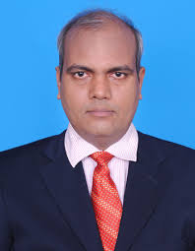

PhD : Anna University, Chennai , Power Electronics and Drives, January-2012
M. Tech: Visveswaraiah Technological University, Belgaum, Karnataka, June-2003
Teaching & Research Experience: 16 years

Research interest

Power Electronics and Drives: Converter, Inverters, DC-DC converter, AC Drives, DC Drives and control
Power System: Power Quality improvement, FACTS, HVDC
Energy System: Renewable Energy System.
No of Publication: In International Journal: 16

Ph.D- Supervisor of Anna University Chennai, Presently guiding 9- Ph.D students.

