Dr.N.Muthukrishnan Professor of Mechanical Engineering email: mk@svce.ac.in; neepz1@gmail.com Phone : 91 44 27152000 Ext.402
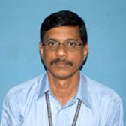

PhD - Jawaharlal Nehru Technological University – Machining of Metal Matrix Composites, Nov 2009
MS - Technological operations, Birla Institute of science and Technology (BITS),Pilani, Rajasthan, INDIA , -,Nov – 1993.
BE - Production Engineering, College of Engineering, Guindy, Anna University, Chennai, INDIA, 1986.
Teaching and Research Experience - 28 years

Research interest

METAL CUTTING & FORMING TECHNIQUES
Machining of Composites, alloys, ceramics, difficult to cut metals, Optimization techniques, artificial neural networks, fabrication of composites, modeling of Non- conventional machining.

