|  |
| --- |
|  |
| **Dr.NACHIAPPAN NACHIAPPAN**  **Assistant Professor of Applied Chemistry**  **email:nachiappan@svce.ac.in; nachi266k.energy@gmail.com**  **Phone: 91 44 2715 2000 Ext. 169** |
|  |
|  |

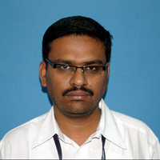

PhD Alagappa

University Karaikudi, PEM Fuel Cell

SPIC Science Foundation, India 2014

MSc Alagappa

University, India. Chemistry

May 2001

Teaching & Research Experience: 15 years

**Research interest**

**Electro Chemistry, Batteries, Hydrogen Energy, Polymer Electrolyte Membrane Fuel Cell & Electro Inorganic Chemicals**