Dr. S. Ponnuvel Associate Professor, Department of Mechanical Engineering, Sri Venkateswara College of Engineering, Sriperumbudur 602117. email:ponnuvel@svce.ac.in phone: 91 44 27152000 Ext. 401, 415 Mobile: 8939329433
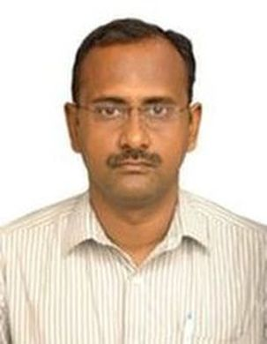

Ph.D Anna University Composite Materials
2016
ME Anna University Computer Integrated Manufacturing
2004
Teaching & Research Experience: 15 years
Research interest

Materials Characterization
Mechanics of Machining
Composite Materials
Optimization techniques
Modern Manufacturing Methods
Nanomaterials

