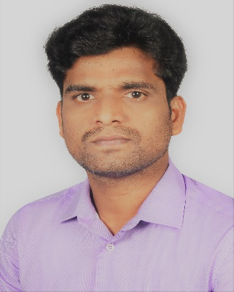
Dr. KANNADASAN R
Assistant Professor,
Dept. of Electrical and Electronics Engineering,
Email: kannadasanr@svce.ac.in; kannan.3333@yahoo.co.in
Phone: 91 44 27152000

Ph. D | Anna University, Chennai, India | Electrical Engineering,  2018
M. E | Anna University, Chennai, India | Power systems Engineering, 2013
B. E | Anna University, Chennai, India | Electrical and Electronics Engineering,  2010
Teaching & Research Experience: 7 years
Research Interest

- Flexible AC Transmission Systems (FACTS),
- Metal oxide surge arrester,
- Very Fast Transient Overvoltage’s,
- Electrical transients,
- Insulation co-ordination,
- Synthesis of metal oxide nanoparticles
- Advanced material processing
- Power Electronics
- Waste management system
- Internet of Things (IoT)

