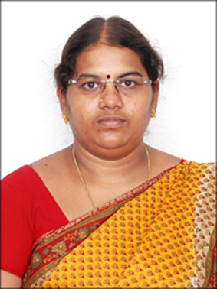
Dr. R.Gayathri
Associate Professor, Electronics and Communication Engineering
Email: rgayathri@svce.ac.in; gayathricontact@gmail.com
Mobile: 91 442715 2000 Ext.228

Academic Credentials:
PhD. Information and Communication
Anna University, College of Engineering Guindy, Chennai.
Year of passing: Dec. 2014.

M.Tech. Laser & Electro Optical Engineering
Anna University, First Class
College of Engineering Guindy, Chennai.
Year of passing: Dec. 2001

B.E. Electronics and Communication Engineering
Madras University, First Class
Arunai Engineering College, Thiruvannamalai 606602.
Year of passing: April 1999

Teaching Experience and Research Experience: 16 Years
Publications
International Journal: 21
International Conferences: 11
Research Interest
My main research interests are in the field of computer vision, pattern recognition, VLSI signal processing and machine learning for video analytics with the focus on human tracking and event/activity recognition in video. I developed several algorithms for image and video analysis including detection and tracking of humans in video, motion estimation, multi-resolution video processing, biologically-inspired spatial-temporal filtering, local video event detection, and action classification.

