Dr R Muthucumaraswamy Professor and Head Department of Applied Mathematics email:msamy@svce.ac.in Phone: 91 44 2715 2000 Ext. 155
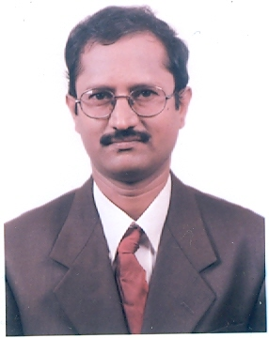

PhD Anna University. , Theoretical and Computational Fluid Dynamics

MSc MIT, Anna University. Applied Mathematics, 1987

Teaching & Research Experience: 27 years

Research interest

Theoretical and Computational Fluid Dynamics: Theoretical and numerical study of unsteady flow past vertical plate in the presence of heat and mass transfer

Key areas: Heat and mass transfer, Radiative heat transfer, chemical kinetics, Hall effects, rotating fluid and Magnetohydrodynamics

