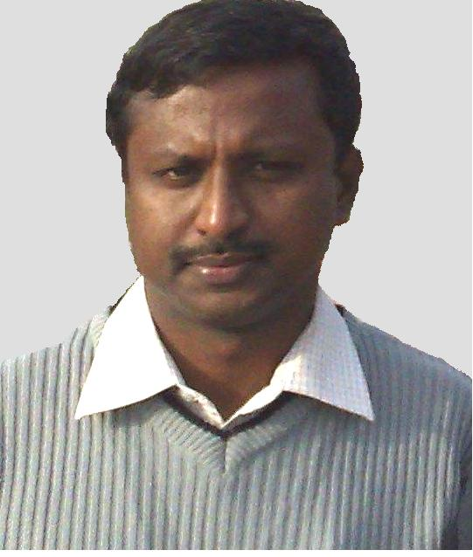
Dr. R.Ramesh Professor of Mechanical Engineering email:rameshraja@svce.ac.in; Phone: 91 44 2715 2000 Ext.403

Qualification
B.E.-Mechanical Engineering- 1995-University of Madras
M.E.-Computer Aided Design- 2001-University of Madras
Ph.D.-Mechanical Engineering- 2006-Indian Institute of Technology, Madras
Teaching & Research Experience: 18 Years
Research interest
- Tribology
- Mechanical Behaviour of Engineering Materials
- Vibration Analysis
- Fiber reinforced Polymer (FRP) Composite materials and analysis

