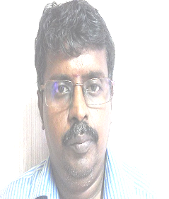
Prof. G.A.Sathish Kumar
Professor of Electronics and Communcation Engineering
email: sathish@svce.ac.in
Phone: 91 44 2715 2000 Ext. 203

PhD Anna University , Information and Communication Engineering November 2012
M.E PSG College of Technology Applied Electronics
March 1998
Teaching & Research Experience: 17 years
Research interest

Networking and Network Security : Development of new algorithms for network security, clustering based location identification for WSN, Light weight cryptography, Design of new S Box for modern cipher.
VLSI: Low power VLSI circuits, DD3 logic & vedic mathematics based VLSI circuits for wireless and signal processing applications.

