Dr. S.G.BHARATHI DASAN Associate Professor Department of Electrical and Electronics Engineering, email:bharathi@svce.ac.in; Phone: 91-44 2715 2000 Ext. 351

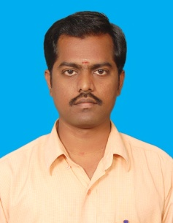

PhD CEG -Anna University Chennai Electrical Engineering
October 2014
M.E CEG- Anna University Chennai Power systems Engineering
January 2002
BE Anna University Chennai Electrical and Electronics Engineering
April 1999
Teaching & Research Experience: 13.7 years

Research interest

Steady state and dynamic analyses of Power System.
[Wind Energy Conversion system/Flexible AC Transmission systems]
Design of controllers for Power Electronics control of drives

