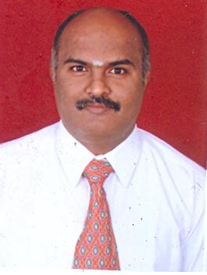 | Dr. S. RAMESH BABU,  Associate Professor  Department of Mechanical Engineering  Sri Venkateswara College of Engineering  Pennalur, Sriperumbudur – 602117  http://www.svce.ac.in/departments/mech/profile/index.php?id=MEC5342000

Degree | Specialization | University | Year of Completion
B.E. | Mechanical Engineering | University of Madras | April 1993
M.E. | Production Engineering - Manufacturing Automation | Madras Institute of Technology,  Anna University | February 1996
Ph.D. | Metal Forming – Manufacturing Engineering | Anna University | January 2014

Research
Recognized as a Research Supervisor by Anna University for guiding M.S.(By Research) and Ph.D. scholars (Supervisor No- 2520019)

Research Areas
- Metal Forming
- Metal Cutting / Machining
- Friction Stir Welding / Processing / Surfacing
- Severe Plastic Deformation (Equal Channel Angular Pressing, Twist Extrusion)
- Superplastic Forming
- Cold Metal Transfer Welding
- Composites using E-waste
Facilities Available in SVCE
- Cold Metal Transfer welding, Pulsed MIG welding, Friction Stir welding
- Superplastic forming
- Hydraulic Press- 200 Tonne capacity
- CNC lathe, Centreless grinding machine

