Prof. S.SAMPATH KRISHNAN Professor & Head of APPLIED PHYSICS email: sambathk@svce.ac.in Phone: 91 44 2715 2000 Ext. 170
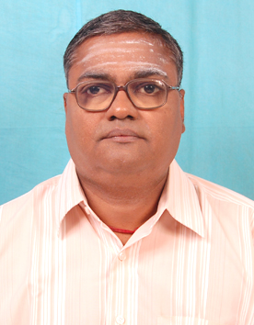

PhD. Anna University
College of Engineering Spectroscopy
Chennai, India Jan 1990
M.Phil Anna University
College of Engineering Spectroscopy
Chennai, India Jan 1987
MSc Bharathidasan University, Physics
Tiruchirappalli,India June 1985
Teaching & Research Experience: 25 years
Research interest

- Quantum chemical computations using ab initio and Density Functional Theoretical methods for geometry Optimization and vibrational spectral prediction of Biomolecules for analysis of experimental results
- Growth and characterization of Crystals. Raman, IR & SERS investigations of NLO crystals.
- Vibrational spectral studies of natural product Molecules with medicinal properties

