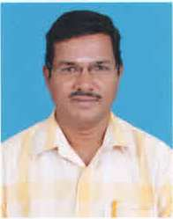
Prof. Dr.S.SARAVANAN
Professor of Mechanical Engineering
email:saran@svce.ac.in
Phone: 91 44 2715 2000 Ext. 404
Name of the Degree | Name of the College /University | Year | Subjects taken for specialization
Ph.D | Anna University Chennai | March 2013 | IC Engines
M.E | Madras University | 2002 | Thermal Engineering  (University Third Rank)
M.M.M | Alagappa University | 1998 | Marketing
Teaching & Research Experience: 22 years
Research interest
IC ENGINES: Diesel engine- combustion-Emission control-Alternate fuels-Engine modification-Theortical investigation-NOx and smoke reduction- Automotive engine-CRDI engine
BIODIESEL: Production-Engine testing- Effect of saturated and unsaturated fatty acids- feasibility
HIGHER ALCOHOLS- Suitability-Engine testing-Emission control-engine modifications
OPTIMIZATION- Taguchi techniques-ANOVA-DOE- MRSN-Multi response optimization

