Dr. S. STANLY Assistant Professor, Applied Chemistry email: stanly@svce.ac.in Phone: 91 44 2715 2000 Ext. 858

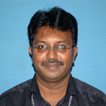

Ph.D. Anna University Chennai Chemistry
December 2005
M.Sc. Bharathidasan University Environmental Science
June 1993
B.Sc. Madras University General Chemistry
June 1990
Teaching & Research Experience: 22 years

Research interest

Waste water treatment using Activated carbon materials
Photo catalysis – Color removal and Dye degradation studies.

