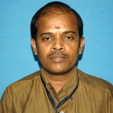
Dr.M.THIRUMALAIKUMAR
Assistant Professor
Department of Applied Chemistry
Sri Venkateswara College of Engineering
Pennalur, Sriperumbudur – 602 117.

Ph. D Madurai Kamaraj University, School of Chemistry, Madurai, March 1998.
M. Sc. Madurai Kamaraj University, ANJA College, Sivakasi, May 1991.
PDF University of Zaragoza, Zaragoza, Spain, 2003.
The Hebrew University of Jerusalem, Jerusalem, Israel, 2001.

Teaching & Research Experience: 16 years

Research interest

Organic Chemistry – synthesis, characterization and antimicrobial activity of organic compounds.

