Dr. Murugavel T Prof & Head- Department of HSS email:hodhs@svce.ac.in; mcwhale@svce.ac.in Phone: 9884822393 Ext. 150
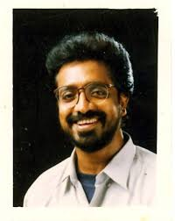

Ph.D in English Language Teaching (Title: Problems of Non-English Medium students in Learning Engineering Subjects in English). Pachaiyappas College, University of Madras, 2005.
M Phil – English Literature - Pachaiyappas College, University of Madras, 1989.
Teaching & Research Experience: 27

RESEARCH INTEREST
Area of Interest in English Language Teaching:
Teaching English to students from Non-English Medium background – Using authentic materials for language teaching – Identifying and solving barriers in language learning.
Research Focus: The exposure the foreign learners (non-native speakers) especially students from a non-English medium background have in using English to communicate is very minimal in schools and colleges and never have they used English language with friends and folks. The Research Work always focuses in identifying problems like wrongly associating English words with different regional expressions and environmental influences or regional language influences.

