SRI VENKATESWARA COLLEGE OF ENGINEERING
Office of Dean (Research)
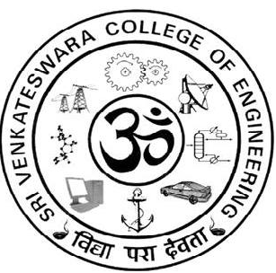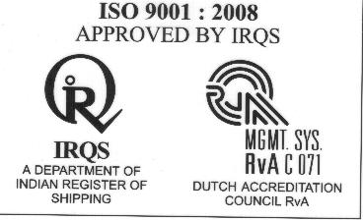
List of PG projects selected for intramural funding for the Year 2016-2017
1. Chemical Engineering

S.No | Name of the Student | Title of the Project | Name of the supervisor with Designation | Amount sanctioned
1 | S. Karthick  M Tech  (Chemical Engineering) | “Study on Robustness of Continuous Adsorption Column with Membrane Filtration on Bio sorption of Heavy Metals” | 1. Dr. R. Palani,  Associate Professor  2.Mr. D. Sivakumar  Assistant Professor | Rs.10.000/-  (Rupees Ten Thousand only)

2. Mechanical Engineering

S.No | Name of the Student | Title of the Project | Name of the supervisor with Designation | Amount sanctioned
1 | P.K. Dinesh Kumar,  M.E., (Computer Aided Design) | Friction and wear behavior of polyetheretherketone-polytetrafluroethelene composite reinforced with nano aluminium oxide | Dr. R. Ramesh,  Professor | Rs.10.000/-  (Rupees Ten Thousand only)

3. Department of Electrical and Electronics Engineering

S.No | Name of the Student | Title of the Project | Name of the supervisor with Designation | Amount sanctioned
 | V. Sanghavee  M.E. (Power Electronics and Drives) | A Symmetric Multilevel voltage source inverter with reduced number of power switches | Dr. R. Karthikeyan,  Associate Professor | Rs.10.000/-  (Rupees Ten Thousand only)

4. Department of Electronics and communication Engineering

S.No | Name of the Student | Title of the Project | Name of the supervisor with Designation | Amount sanctioned
1. | K. Jothilakshmi,  M.E. (Communication  Systems) | Implementation of Low mass multilayer body worn antenna for WBAN Medical applications | Dr. P. Jothilakshmi,  Professor | Rs.10.000/-  (Rupees Ten Thousand only)
2 | Nadar James Francis Joseph Roy  M.E. (Applied Electronics) | Folded VLSI Architecture for adaptive digital filter used in echo cancellation | Dr. S.R. Malathi,  Associate Professor | Rs.10.000/-  (Rupees Ten Thousand only)

5. Computer Science and Engineering

S.No | Name of the Student | Title of the Project | Name of the supervisor with Designation | Amount sanctioned
1 | - Priyadharsini  M.E. (Computer Science and Engineering) | Sign Language recognition using convolutional neural networks | Ms. N. Rajeswari,  Assistant Professor | Rs.8.000/-  (Rupees Eight Thousand only)

6. Biotechnology

S.No | Name of the Student | Title of the Project | Name of the supervisor with Designation | Amount sanctioned
1 | N. Anuradha  MTech (Biotechnology) | Engineering MSC Derived bone tissue using 3D printed PCL scaffold and Litsea glutinosa Bark extract. | Dr. Nalinkanth V. Ghone,  Professor | Rs.10.000/-  (Rupees Ten Thousand only)

7. Information Technology

S.No | Name of the Student | Title of the Project | Name of the supervisor with Designation | Amount sanctioned
1 | A.V. Vivekia  M.E. Computer Science and Engineering (with specialization in Networks) | Generic Bio-inspired cyber security in SIWC model for WSN | Dr. N. Kumaratharan,  Professor | Rs. 10,000/- (Rupees Ten Thousand only)
(Seventy eight thousand only) Total : 78,000/-



Dr. R. Muthucumaraswamy,
Dean (Research)

