SRI VENKATESWARA COLLEGE OF ENGINEERING
Office of Dean (Research)
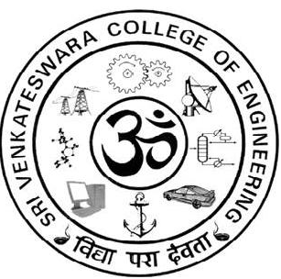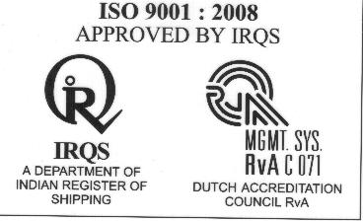

List of Student Research projects selected for funding in the year 2015-2016

B.E. Mechanical Engineering

S.NO | STUDENT NAME | PROJECT TITLE | NAME OF THE GUIDE AND DEPARTMENT |  | FUND RECOMMENDED WITH AMOUNT
 | R. Badri Narayanan,  J. Deepak Kumar,  K.N. Kavin Kumar | Microstructure and mechanical properties of cold metal transfer welded thin sheet AA6061 | Dr. S. Ramesh Babu,  Associate Professor,  Dept. Of Mechanical |  | Recommended,  Rs.10,000/-
B.E. Department of Electrical and Electronics Engineering

S.NO | STUDENT NAME | PROJECT TITLE | NAME OF THE GUIDE AND DEPARTMENT | FUND RECOMMENDED WITH AMOUNT
 | A. Jones | Modelling of vienna rectifier using hysteresis current Controller and its Applications in Aircraft Industry | - Tamizhselvan,  Asst. Professor, E.E.E. | Recommended,  Rs.10,000/-

B.E. Department of Electronics and Communication Engineering

S.NO | STUDENT NAME | PROJECT TITLE | NAME OF THE GUIDE AND DEPARTMENT | FUND RECOMMENDED WITH AMOUN
 | - Brrindha,  M Chaarmeli,  A.M. Jayasri, | Design and implementation of software defined radio | Dr. G. Padmavathi,  Professor,  Department of E.C.E. | Recommended,  Rs. 9,000/-

B.E. Computer Science and Engineering
S.NO | STUDENT NAME | PROJECT TITLE | NAME OF THE GUIDE AND DEPARTMENT | FUND RECOMMENDED WITH AMOUNT
1 | J.R. Keerthi kumar,  B. Lokesh,  U. Prem Kumar, | Data security in cloud using hybrid homomorphic encryption | Dr. R. Anitha,  Associate Professor,  Dept. Of C.S.E. | Recommended,  Rs.9,000/-

B.E. Automobile Engineering

S.NO | STUDENT NAME |  | PROJECT TITLE | NAME OF THE GUIDE AND DEPARTMENT |  | FUND RECOMMENDED WITH AMOUNT
1 | Kunal.K.Davey,  Ciril Joy,  R.Krishna.  Ankush |  | Load adaptive braking system | Dr. V. Ganesh,  Associate Professor,  Dept. Of Automobile  Engineering. |  | Recommended,  Rs. 9,500/-
B.E. Civil Engineering

S.NO | STUDENT NAME | PROJECT TITLE |  | NAME OF THE GUIDE AND DEPARTMENT | FUND RECOMMENDED WITH AMOUNT
1 | S.B. Vishnu  Prasad | Characterization of magneto rheological gels |  | Dr. P. Venkateswara rao,  Associate Professor,  Dept. Of Civil Engineering. | Recommended  Rs. 9,000/-

B.E. Marine Engineering
S.NO | STUDENT NAME | PROJECT TITLE | NAME OF THE GUIDE AND DEPARTMENT | FUND RECOMMENDED WITH AMOUNT
1 | P. Sivasankar,  C, Sivasankaran,  R. Sabastin | Remote control of two ram electro hydraulic steering gear system | Mr.R. Somasundaram,  Asst. Professsor,  Marine Engineering | Recommended,  Rs.10,000/-

B. Tech. Information Technology

S.NO | STUDENT  NAME | PROJECT TITLE |  | NAME OF THE GUIDE AND DEPARTMENT | FUND  RECOMMENDED  WITH AMOUNT
1 | - Aneesha Banu,  B. Atchiya Bharathi,  R. Kiruthika. | A Secure Biometric-Based Authentication Protocol |  | Ms. A. Kala,  Assistant Professor,  Department of I.T. | Recommended,  Rs.7,000/-
B.Tech. Biotechnology

S.NO | STUDENT NAME |  | PROJECT TITLE | NAME OF THE GUIDE AND DEPARTMENT |  | FUND RECOMMENDED WITH AMOUNT
 | S. Jayasupriya,  B. Rajalakshmi |  | Value added products from cactus pear | Dr. E. Nakkeeran,  Asso. Professor,  Dept. Of Biotechnology |  | Recommended,  Rs.9,000/-

B. Tech. Chemical Engineering

S.NO | STUDENT NAME | PROJECT TITLE | NAME OF THE GUIDE AND DEPARTMENT | FUND RECOMMENDED WITH AMOUNT
 | M. Naveen  S. Naveen Narayan,  K. Paulrajan. | Closed loop liquid cooling of CPU using nano-field | G. Sudha,  Assistant Professor,  Dept. Of Chemical Engg. | Recommended,  Rs.10,000/-
Total Amount  (Rupees Ninety Two thousand five hundred Only |  |  |  | Rs. 92,500/-



Dr. R. Muthucumaraswamy,
Dean Research,
S.V.C.E,

