SRI VENKATESWARA COLLEGE OF ENGINEERING
Office of Dean (Research)
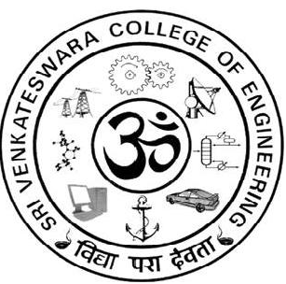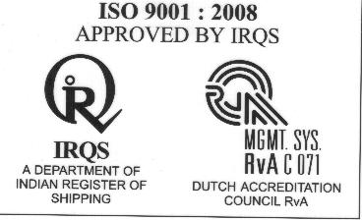

List of UG Student Research projects selected for Intramural funding for the
Academic year 2016-2017
Mechanical Engineering

S.NO | STUDENT NAME | PROJECT TITLE |  | NAME OF THE GUIDE AND DEPARTMENT |  | FUND RECOMMENDED (WITH AMOUNT)
1. | 1. Harish  Bharadwaj. G,  2. Sughosh.D  3. Vigneshwar. S | Influence of routes A,BC &C on Mechanical properties of AA6061 Subjected to ECAP |  | Dr. S. Ramesh Babu,  Professor & HOD / Mechanical |  | Recommended  Rs.10,000/- (Ten Thousand Only)
Electronics and Communication Engineering
Department of Electrical and Electronics Engineering

S.NO | STUDENT NAME | PROJECT TITLE | NAME OF THE GUIDE AND DEPARTMENT | FUND RECOMMENDED (WITH AMOUNT)
 | 1. Muthiah.M,  2. Kailash.S.  3. Dinesh.R,  4. Mohana  Krishnan | Smart Glove to aid people with movement disability | Ms.S. Anitha,  Asst. Prof. / EEE | Recommended  Rs.8,000/- (Eight Thousand Only)

S.NO | STUDENT NAME |  | PROJECT TITLE | NAME OF THE GUIDE AND DEPARTMENT | FUND RECOMMENDED (WITH AMOUNT)
1. | 1. S. Keerthipriya  2. L. Naveed  Ahmed  3. T.V. Prashanth |  | Gesticulation Based Smart surface with enhanced Biometric security using raspberry Pi. | Dr. R. Gayathri,  Associate Professor, /ECE | Recommended  Rs.10,000/- (Ten Thousand Only)

Computer Science and Engineering
S.NO | STUDENT NAME | PROJECT TITLE | NAME OF THE GUIDE AND DEPARTMENT | FUND RECOMMENDED (WITH AMOUNT)
1 | 1.Krishnan.S,  2.Sachin.S,  3.Balasubramanian T. | Intelligent Intrusion detection system using a committee of experts | Ms.S.Poorani,  Asst. Prof. / CSE | Recommended  Rs.7,000/- (Sevenn Thousand Only)

Marine Engineering
S.NO | STUDENT NAME |  |  | PROJECT TITLE | NAME OF THE GUIDE AND DEPARTMENT | FUND RECOMMENDED (WITH AMOUNT)
1. | 1. K. Jasvant  Kumar  2. M. Vasanth  Kumar  3. J.Senthamizarasan |  |  | Overhauling and commissioning of engine in lifeboat & Fabrication of Rudder and alignment of propeller shaft. | Prof. Dr. S. Krishnan,  Professor & HOD / Marine | Recommended  Rs.10,000/- (Ten Thousand Only)
Automobile Engineering

S.NO |  | STUDENT NAME | PROJECT TITLE |  | NAME OF THE GUIDE AND DEPARTMENT |  | FUND RECOMMENDED (WITH AMOUNT)
1 |  | 1.Chidambaram.SP | Variable braking force system using intelligent twin caliper system |  | Dr. V.Ganesh,  Associate Prof. /  Automobile |  | Recommended  Rs.10,000/- (Ten Thousand Only)

Chemical Engineering

S.NO | STUDENT NAME |  |  | PROJECT TITLE | NAME OF THE GUIDE AND DEPARTMENT | FUND RECOMMENDED (WITH AMOUNT)
 | 1. Kiran Prabhu  2. Gayathri. B  3. Aadityan. A |  |  | Experimental validation of ethanol recovery from fermenter product using dibutyl phthalate | 1. Mr. S.Jai Ganesh,  Assistant Professor /  Chemical  2. Dr. R. Govindarasu,  Associate Professor /  Chemical | Recommended  Rs.9,000/- (Nine Thousand Only)
Information Technology

S.NO | STUDENT NAME | PROJECT TITLE |  |  | NAME OF THE GUIDE AND DEPARTMENT | FUND RECOMMENDED (WITH AMOUNT)
1 | 1. S.Abinaya,  2. Ashika  3. P.Ezhimathi | Hybrid clustering analysis of cardiovascular disease |  |  | Mrs. P. Leelarani,  Asst. Prof. / I.T. | Recommended  Rs.10,000/- (Ten Thousand Only)
Biotechnology

S.NO | STUDENT NAME |  | PROJECT TITLE |  | NAME OF THE GUIDE AND DEPARTMENT |  | FUND RECOMMENDED (WITH AMOUNT)
 | 1. S.Naresh kumar  2. M. Akila |  | Effect of Boeravinone B on  DCs - T-Cell Interaction |  | 1. Dr. M. Sivanandham /  Visiting Professor /  Biotechnology &  Secretary,  2. Mr.P. K. Praveen  Kumar, Asst. Prof. /  Biotechnology |  | Recommended  Rs.9,000/- (Nine Thousand Only)
 | (Rupees Eighty three thousand only |  |  |  |  |  | Rs.83,000/-


Dr. R. Muthucumaraswamy,
Dean Research

