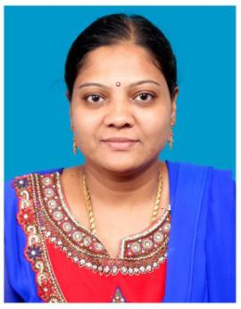 | Dr. R.Kumutha  Professor & Head  Department of Civill Engineering  Sri Venkateswara College of Engineering  Pennalur, Sriperumbudur – 602117  https://www.svce.ac.in/profile-info/?id=6391

Degree | Specialization | University | Year of Completion
B.E. | Civil Engineering | Madurai Kamaraj University | April 1997
M.E. | Structural Engineering | Madurai Kamaraj University | November 1998
Ph.D. | Civil Engineering | Anna University, Chennai | April 2007

Research
Recognized as a Research Supervisor by Anna University for guiding M.S.(By Research) and Ph.D. scholars (Supervisor No - 2010057 )

Research Areas
- Strengthening of structures using FRP Composites
- Geopolymer Composites
- Sustainable Building materials
- Steel – Concrete Composite Structures

