Dr. R. Suresh Assistant Professor, Department of Applied Mathematics , Sri Venkateswara College of Engineering, Sriperumbudur 602117. E-mail:rsuresh@svce.ac.in Phone: 91-44-27152000 - Ext. 159 Mobile: +91-8124605087
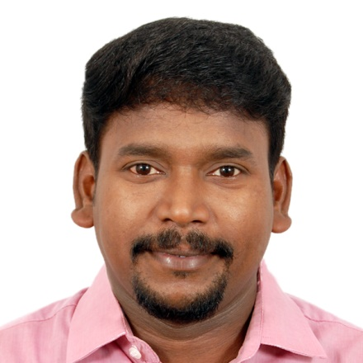

Ph.D Sri Ramakrishna Mission Vidyalaya CAS Mathematics 2017
M.Phil Sri Ramakrishna Mission Vidyalaya CAS Mathematics 2010
M.Sc Sri Ramakrishna Mission Vidyalaya CAS Mathematics 2007

Teaching & Research Experience: 12 years

Research Interest

Stability Analysis of Dynamical Systems
Neural Networks
Control Systems
Differential Equations

