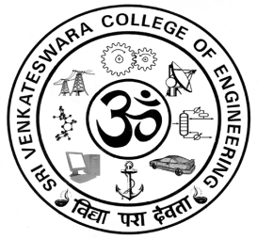

Office of the Dean (Research)

Research Advisory Committee
The following is the list of Internal/External Expert members of the Research Advisory Committee/Board, to monitor the progress of research activities in Sri Venkateswara College of Engineering, Pennalur, Sriperumbudur 602 117.

- Dr S Ganesh Vaidyanathan Member
Principal, SVCE

- Dr K R Santha Member
Vice Principal, Professor and Head
Department of Electrical and Electronics Engineering
SVCE

- Dr K Pitchandi Member
Professor and Controller of Examinations-SVCE
Department of Mechanical Engineering
SVCE

- Dr R Anitha Member
Professor and Head
Department of Computer Science and Engineering
SVCE

- Dr C Balaji External Member
Professor, Heat Transfer& Thermal Power Laboratory
Department of Mechanical Engineering
Indian Institute of Technology Madras
Chennai 600 036

- Dr P Loganathan External Member
Professor, Department of Mathematics
Anna University, Chennai 600 025.

- Dr V Jeyalakshmi External Member
Professor
Department of Electronics and Communication Engineering
Anna University, Chennai 600 025.

- Dr R Baskaran External Member
Professor and Additional Controller of Examinations
Department of Computer Science and Engineering
Anna University, Chennai 600025.

- Dr Karunagaran Devarajan External member
Professor Emeritus
414, Department of Biotechnology
Bhupat & Jyoti Mehta School of Biosciences Building
Indian Institute of Technology Madras
Chennai-600 036

- Dr R Muthucumaraswamy Convener
Dean (Research), Professor and Head
Department of Applied Mathematics, SVCE.

