Dr. C.Kamal Assistant Professor, Department of Electrical and Electronics Engineering, Sri Venkateswara College of Engineering, Sriperumbudur 602117. email:kamalc@svce.ac.in phone: 91 44 27152000 Ext. 251, 265 Mobile: +91 9791121025
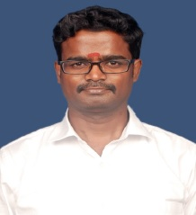

Ph.D MIT Campus, Anna University Electrical Engineering
2021
M.E. GCT, Coimbatore, Anna University Power systems Engineering
2006
B.E. Madras University EEE
2002
Teaching & Research Experience: 17 years

Research interest

Special Electrical Machines
Electrical Vehicle
Modeling and Control
Optimization techniques
Power System Stability

