Dr. A.Sankaran Assistant Professor, Department of Marine Engineering, Sri Venkateswara College of Engineering, Sriperumbudur 602117. email:sankarana@svce.ac.in phone: 91 44 27152000 Ext. 501, Mobile: 9952524142
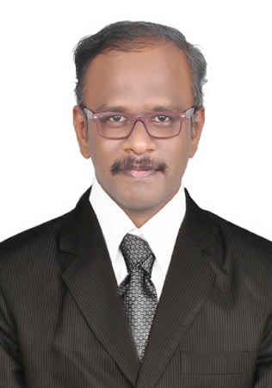

PhD Anna University : Industrial waste water treatment
2021
M.Tech Anna University : Coastal Management
2009
Industry, Teaching & Research Experience: 12.5 years
Research interest

Coastal Pollution
Industrial waste water treatment
Nano composites.
Nano materials.
Catalytic activity

