Dr. S S Sethuraman Associate Professor, Department of Electrical and Electronics Engineering, Sri Venkateswara College of Engineering, Sriperumbudur 602117. email:sethuram@svce.ac.in phone: 91 44 27152000 Ext. 251, 260 Mobile: +91 9566270056
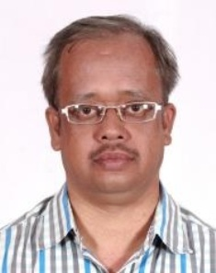

Ph.D SVCE, Anna University Electrical Engineering
2021
M.E. GCT, Coimbatore, Anna University Power Electronics and Drives
2005
B.E. Bharathidasan University EEE
1998
Teaching & Research Experience: 21.6 years

Research interest

DC-DC Converters
DC Microgrids
Renewable Energy Applications
Electric Vehicles

