Dr.R.Sathia Associate Professor, Department of Civil Engineering, Sri Venkateswara College of Engineering, Sriperumbudur 602117. email:sathiamunish@svce.ac.in Mobile: 9790949768
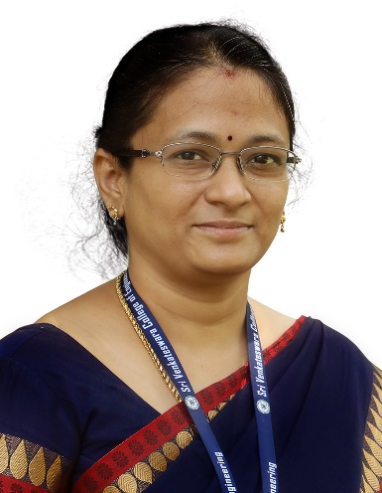

Degree | Specialization | University | Year of Completion
B.E. | Civil Engineering | Madurai kamaraj University | 2001
M.E. | Structural Engineering | Madurai kamaraj University | 2003
Ph.D. | Ocean Engineering | IIT Madras | 2011

Teaching and Research Experience: 18 years

Recognized as a Research Supervisor by Anna University for guiding M.S. (By Research) and Ph.D. scholars (Supervisor No- 3910017)
Research Areas
Research interest
- Geopolymer Concrete
- Non-Destructive Testing
- Ternary Concrete Mix
- Corrosion Studies
- Durability Studies

