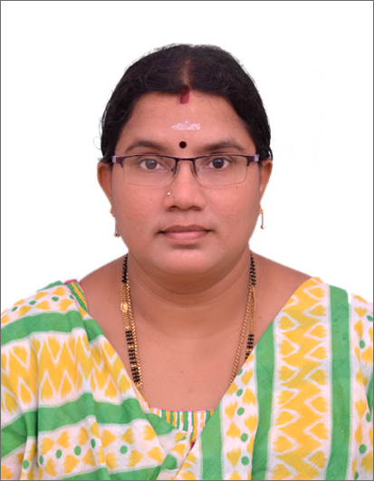 | Dr. V. Sumitha DST-SERB TARE FELLOW Asst. Head & Associate professor Department of Biotechnology Sri Venkateswara College of Engineering Sriperumbudur Tk. 602105 Email ID: Sumitha@svce.ac.in Ph: 044-27152000, Extn: 578/576

Academic Profile
Ph.D – Faculty of Technology, Anna University-2020
M.Tech -Industrial Biotechnology - Annamalai University-2005
B.Tech -Chemical Engineering - Madras University-2002
TARE research fellow – IIT Madras (2020-2023)
Teaching & Research Experience: 18 years

Research Interest

Bioprocessing: Converting biological waste into novel products - animal feed from bagasse, protease, lactic acid, polyhydroxybutyrate and bioethanol using crude glycerol from the biodiesel manufacturing process. Process optimization for enhance product yield and recovery.
Metabolic engineering: Pathway modification for the expression of targeted metabolites. Molecular optimization for the overexpression of genes.

