Dr.K.Vasantharaj Assistant Professor Department of Biotechnology Sri Venkateswara College of Engineering, Sriperumbudur 602117. Email: kvasantharaj@svce.ac.in kvasantharaj@gmail.com Mobile: +91 9600202346
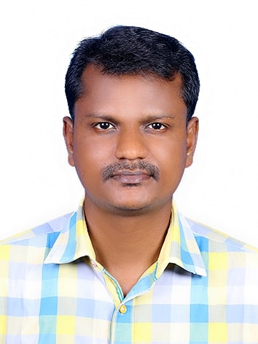

Ph.D | National Institute of Technology Calicut | Chemical Engineering | 2018
M.Tech | SASTRA University Thanjavur | Industrial Biotechnology | 2010
B.Tech | Anna University Chennai | Biotechnology | 2008
Teaching & Research Experience: |  | 11 years

Research interest

Bioprocess Engineering
Sustainable Environment
Biofuels and Bioenergy
Food Biotechnology

