Submitted to the Principal
16th Dec’ 2022
I-CUBE INAUGURATION CEREMONY
Second Edition of i-CUBE -A National level Intercollegiate Technical Event

DATE: 01.11.2022
DAY: TUESDAY
TIMING: 10.00 AM TO 12:00 Noon
VENUE: LIBRARY SEMINAR HALL, SVCE

The Inauguration of the Second Edition of i-CUBE, a National Level Intercollegiate Technical Event organized by the Students’ Council in association with the SVCE Science Club, was held on 1st November 2022.The inauguration began with the invocation and Mr. Anand Kashyap, Chief Executive Officer of SRM Technologies, and Dr. C Shanmugam, Director of the Centre for Science, Promotion, and Research (CSPR), Chennai, served as the day's guests of honor. Dr. M. Sivanandam, Secretary, SVEHT, Dr. S. Ganesh Vaidhayanathan, Principal, SVCE, Dr. R. Muthucumaraswamy, Dean (Research), SVCE, Dr.T. Murugavel, HoD-Humanities accompanied the dignitaries.

The dignitaries launched the second edition of I-CUBE teaser. Dean (Research) welcomed the gathering followed by Dr.N.R. Sheela, Coordinator of SVCE Science Club, briefed on the success of I-CUBE’s first edition and also brief overview about the second edition of I-CUBE, team formation and guidelines of the events INNOWEL and IDEA-O-LITE. On behalf of the Students’ Council and Science Club she thanked the management, Secretary Sir, Principal Sir for their support and encouragement towards I-CUBE.
The Secretary Sir addressed the gathering and he highlights the importance of innovation and research. Further, Secretary sir emphasized everyone should maintain their own library at home and motivated the students to enroll themselves in the events like I-CUBE and appreciated the I-CUBE team for organizing such events across various departments across the states. The Principal addressed the gathering on "Science for Engineers" which gives insight into the significance of Science and Technology and wished the event a great success. Following this, former Students’ Council General Secretary, Mr. Maheeraj introduced the Chief Guest. Mr. Anand Kashyap. Addressed the audience and he stressed on the importance of participation and experiencing the process. Whatever be the end result, the process will be a great learning experience. Ms. Supraja former Students’ Council Secretary introduced the special Guest
Mr Shanmugam. Mr. Shanmugam talked on the nuances of the basics of science and also on HAM radio.
The ceremony concluded with a Vote of Thanks delivered by Mr. Bhavesh. B, President of SVCE Science Club.

INAUGURATION FLYER
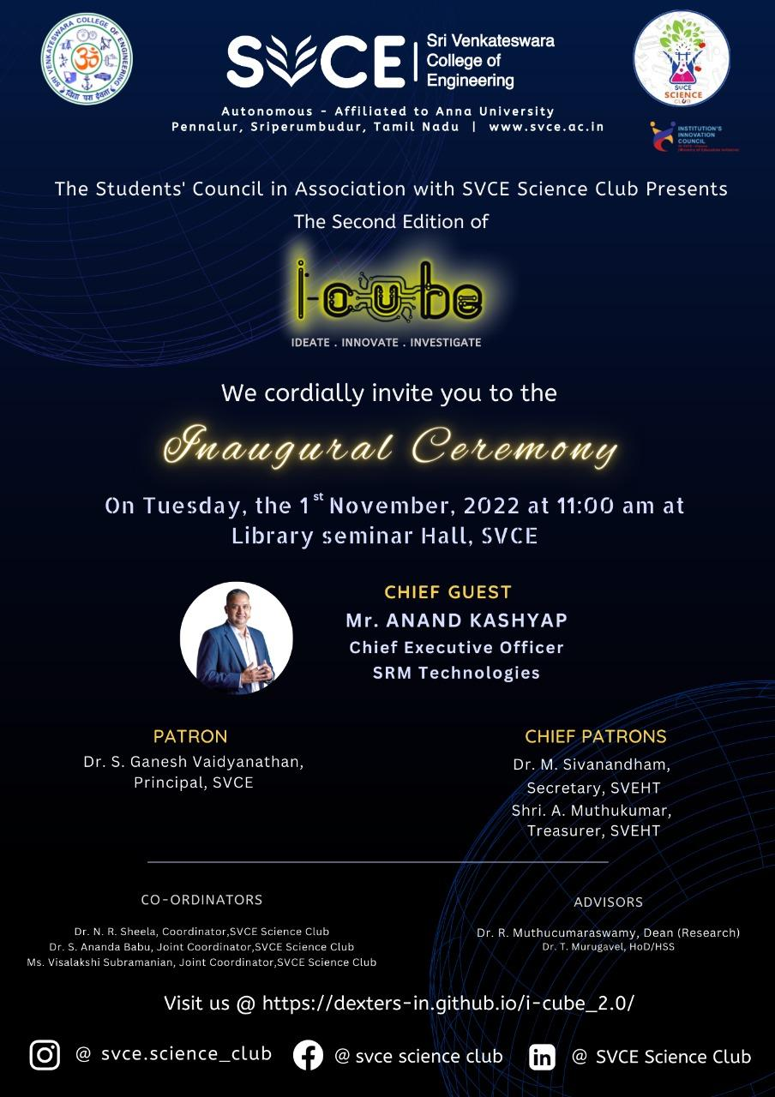

I-CUBE FLYER
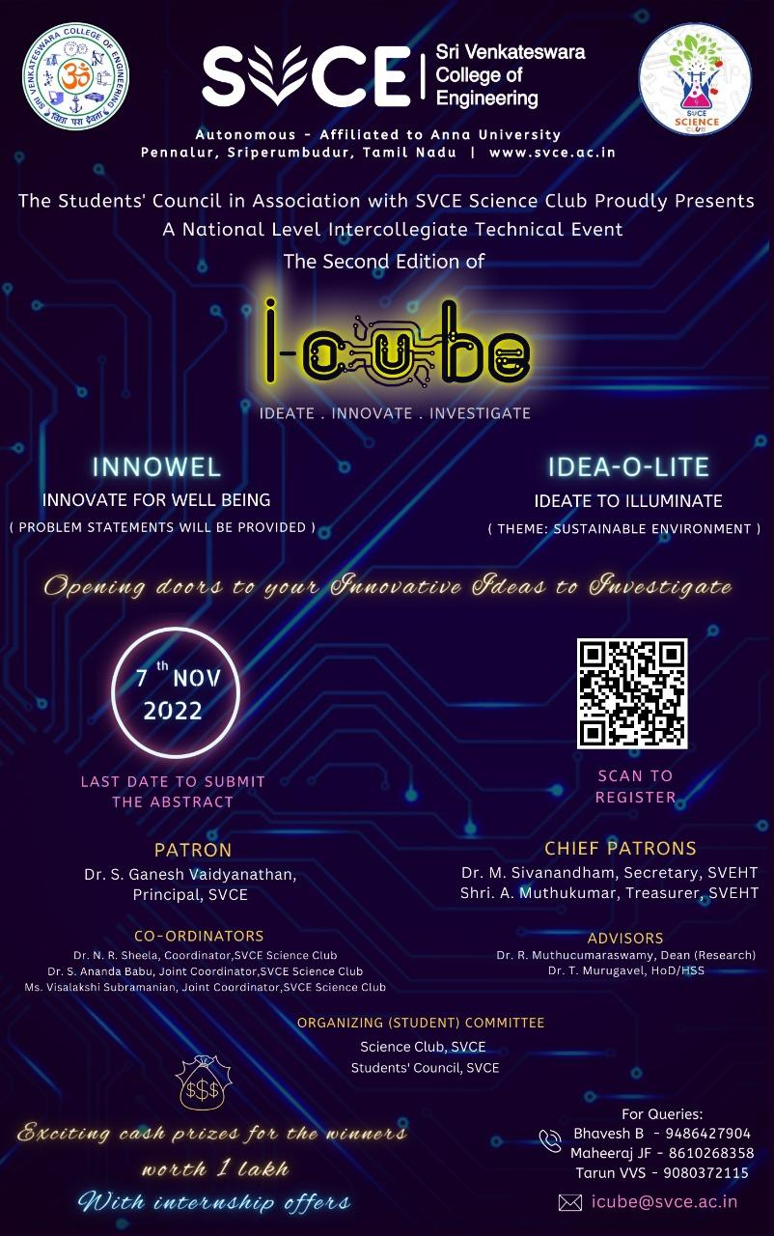

PHOTOS
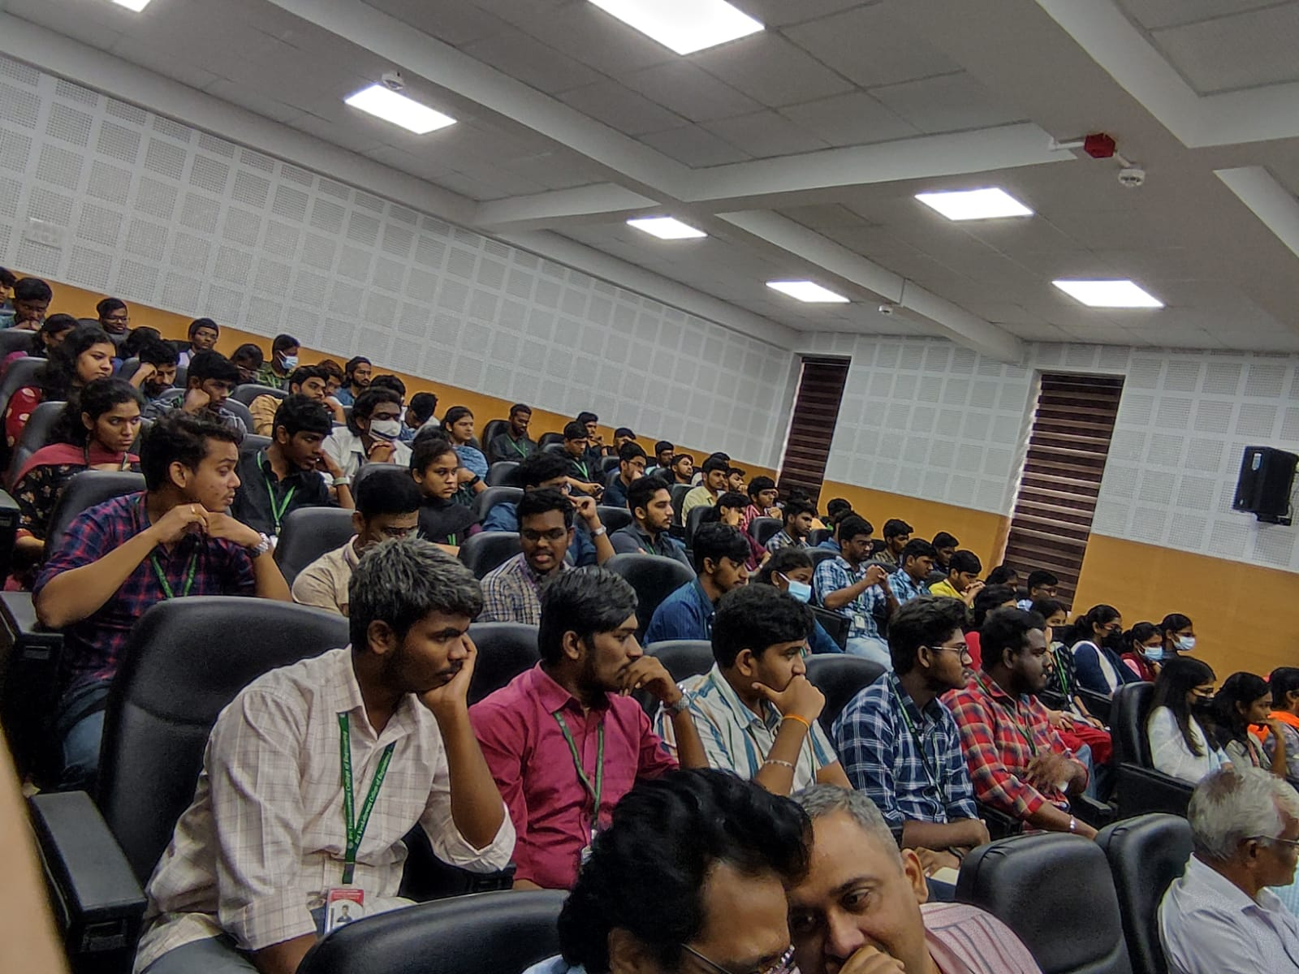
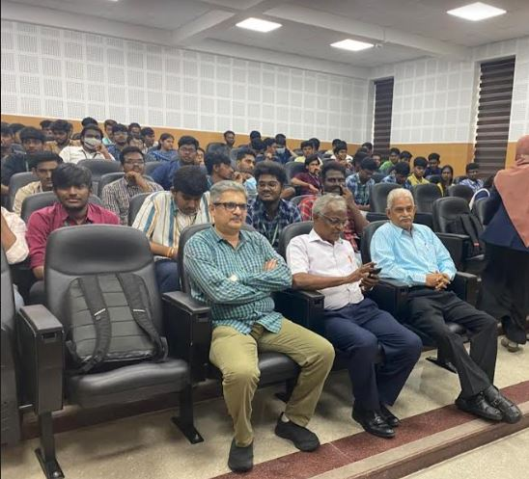

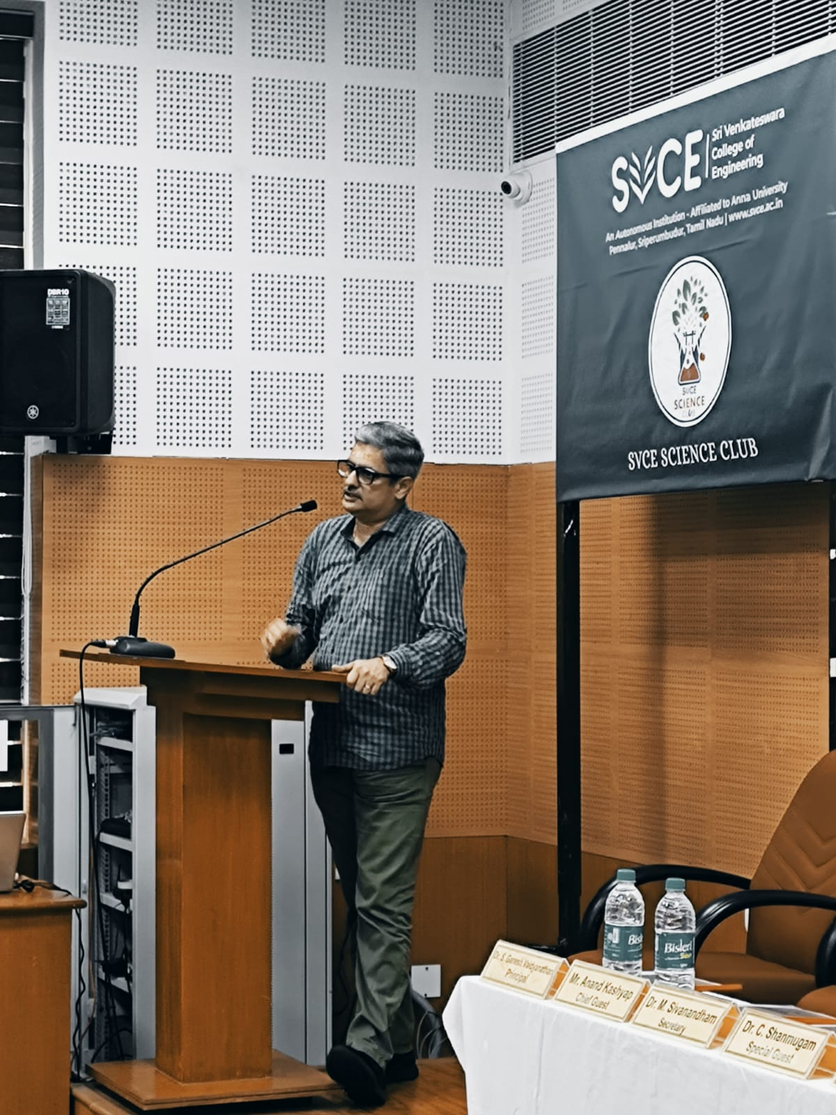
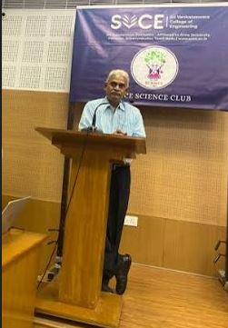

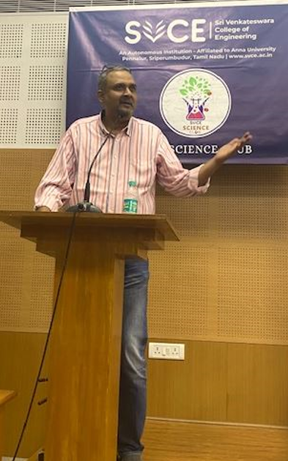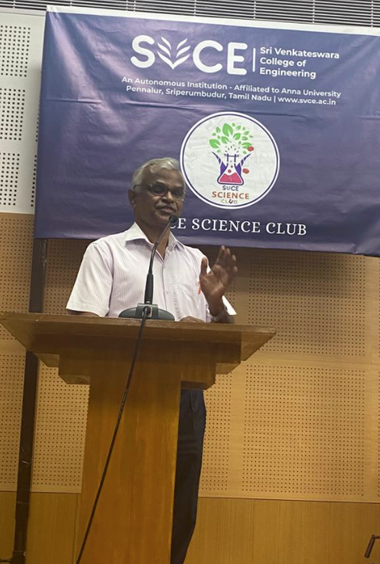
Prepared by
Organizing Team -i-CUBE
For
Dr.N.R.Sheela
(Coordinator SVCE Science Club)

