**Submitted to the Principal**

**16th Dec 2022**

**Phase II of Second Edition of i-CUBE**

**Second Edition of i-CUBE -A National level Intercollegiate Technical Event**

Date : 17th and 18th November , 2022

Day : Thursday and Friday

Venue : Multi Purpose Hall,SVCE.

The Phase II of Second Edition of i-CUBE, a National-Level intercollegiate technical event organized by the Students’ Council in association with the SVCE Science Club was held on 17th and 18th November, 2022.The Phase-I was the scrutinizing of the abstracts submitted by the participants. i-CUBE is the Science Club’s trademark event. Ideate, Innovate, and Investigate are likely the three adjectives that best capture the core of this event. Ideation and innovation refer to the process of creating fresh concepts. Investigate requires assessing the submitted ideas in light of scientific data, originality, and distinctiveness in order to determine whether they are viable and creative in nature. INNOWEL and IDEA-O-Lite are the transcendent events held in I-CUBE. Participants in INNOWEL will get problem statements and work on them in accordance with a set of restrictions. In Idea-O-Lite, the participants are given a theme, they should find a problem and bring the solution according to the statement they have taken.

The event witnessed participation from the top colleges across the nation(MIT Manipal, Keshav Memorial Institute Of Technology-Hyderabad, IIT Madras, VIT,SSN,RMK,RMD,REC,CK College of engineering-Cuddalore, SRM Easwari, Nadar Saraswathi engineering college -Theni, Sri Krishna College Of Engineering-Coimbatore, School of architecture and Planning-Anna University, CIT etc……) where students were encouraged to came up with innovative ideas.

The registrations for the event was open from 1st of November 22. The registrations was closed on 7th of November with 139 responses across the Nation. 74 teams(43 from INNOWEL and 31 from IDEA-O-LITE) were invited for an offline event on 17th and 18th of November 2022.

The shortlisted teams reported at the venue by 9 AM in our college campus on 17th November,2022. The event began with the Ritual of seeking the blessings of the Almighty by reciting the Morning Prayer. The participants were welcomed by Dr. R. Muthucumaraswamy, Dr. T. Murugavel, Dr. N. R. Sheela, Dr.S.Ananda Babu and Ms.Visalakshi Subramanian who extended their hearty wishes to the participants and gave a few words of encouragement to set their spirits high up. Dr.S.Ganesh Vaidyanathan, Principal, Sri Venkateswara College of Engineering  interacted with all 70 teams and appreciated the intercollege and inter departmental collabration in forming the teams to bring out their innovation

The participants of INNOWEL and IDEA-O-LITE were allotted with five tracks and they were sent to their respective venues and they had to present their working models and prototypes in front of the panel members. Students underwent a rigorous evaluation process by both internal members include (Dr. R. Ramesh, Dean Academics, Dr. K. S - Badrinathan, Dean - Educational Development, Dr. J. Venkatesan, Dean - Students' Welfare, Dr.K.Pitchandi-Controller of Examination, Dr.R.Muthucumaraswamy-Dean Research) and external members include Mr.Mohammad Hussain, co-founder @ ALIEN, Mr.Kavin, co-founder @ALIEN &Zoopit, Mr.Athul, CEO Diffusion coatech, MrAshok Kumar-Product Developer, and Mr.Rajamurugan-CEO,Kellyville Business Solutions Pvt.Ltd for Business Pitch.

At the end of the first day of Phase II after their presentation, participants assembled in their allotted work table and continued working on their projects after a small break. Post dinner, a surprise event called “Business Pitch” was revealed by the Coordinators at 11:00 pm wherein the participants had to make a business model of their project to present to them in front of Industrialists visiting on the second day i.e 18th November,2022. Participants were given time till 6:00 am to come up with their strategies.

On the second day (18th November 2022), according to the concocted marketing analysis set by the industrial experts, the participants were asked to present their business ideas in their respective venues. They worked on their given themes, and presented their prototypes pertaining to the standards and the recent trends in which the market values accentuated. The same teams were split into their respective slots, and given a particular timing to which they would be presenting their billboards. Once all the teams finished their presentations, the final judgment was made based on their marketing analysis and their presentation skills, communicative skills, and the winners were decided.

**PHASE II FLYER**

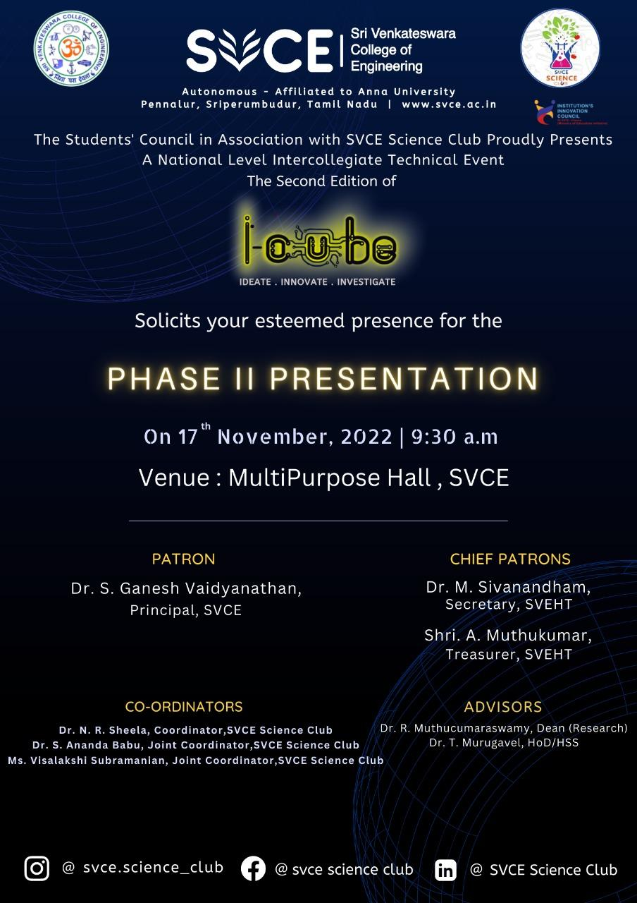

**BUSINESS PITCH POSTER**

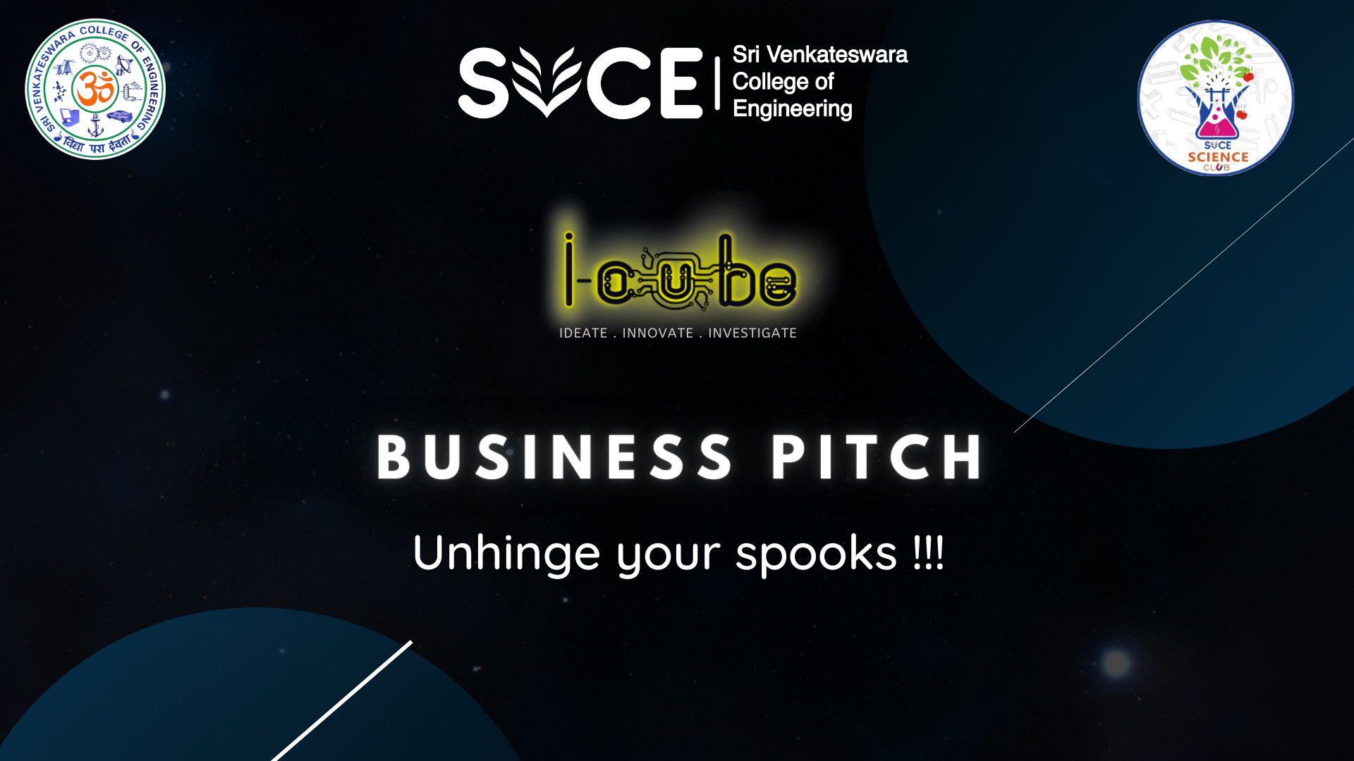

**PARTICIPANT DETAILS:-**

Team Details:

<https://docs.google.com/document/d/1dbaBFjbIcxvU8Rxj44eA0e-IW-5gsmCzsEdOKTNJYeo/edit?usp=sharing>

**INNOWEL:**

| **Teams from SVCE** | **30 teams** |
| --- | --- |
| BOYS | 72 |
| GIRLS | 31 |
| Total Participants - SVCE | 103 Participants |
| **Teams from other colleges** | **13 teams** |
| BOYS | 32 |
| GIRLS | 10 |
| Total Participants - Other College | 42 Participants |

**IDEA-O-LITE:**

|  |  |
| --- | --- |
| **Teams from SVCE** | **24 teams** |
| BOYS | 52 |
| GIRLS | 28 |
| Total Participants - SVCE | 80 Participants |
| **Teams from other colleges** | **7 teams** |
| BOYS | 10 |
| GIRLS | 12 |
| Total Participants - Other College | 22 Participants |

**Track Details**

**Nov17th and 18th**

| **Track details Prototype presentation/Business Pitch** | **Panelists(External/Internal)** |
| --- | --- |
| Venue :Video Hall  INNOWEL | 1.Dr.R.Ramesh  Dean Academics,Prof.MEC  2.Dr.T.Padmavathy  Assistant Professor, CSE  3.Dr.V.Ganesh  Associate Professor,AUT  4.Mr.Kavin  Cofounder @ ALIEN |
| Venue-Function Hall  INNOWEL | 1.Dr.K.Pitchandi  Controller of Examinations  Prof Mechanical Department  2.Dr.M.Selva Kumar  Associate Professor  Department of Civil Engg  3.Dr.Rajesh  Department of Chemical Engg  Associate Professor  4.Mr.S.C.Atul B.E, MS  CEO, Diffuson Coatech |
| Venue-Biotech Conference  Hall   INNOWEL | 1. Dr.J.Venkatesan  Dean Students’ Welfare  Prof and Head AUT  2.Dr.R.Gayathri  Associate Professor, ECE  3.Dr.T.Rajasekaran/Dr.B.Praveen Kumar  Associate Professor, CSE  4.Mr.Mohamed Hussain  Cofounder @ ALIEN |
| Venue-Library Conference Hall  IDEA-O-LITE | 1.Dr.C.Muthucumaraswamy  Dean-Research,Professor and Head,APM  2.Dr.K.Divakar  Associate Professor, BIO  3.Dr.C.Senthamarai Kannan  Associate Professor,MEC  4.Mr.B.S.Raja Murugan  CEO  Kellywille Business Solutions Pvt.Ltd. |
| Venue-QMC  IDEA-O-LITE | 1.Dr.K.S.Badrinathan  Dean-Education Development, Prof. MEC  2.Dr.D.Jayanthi  Associate Professor, INT  3.Dr.M.Sankar,  Assistant Professor, EEE  4.Mr.Askok  Product Manager, IoT Based Company |
| Total No. of Particiapnts | 247 |

**PHASE II-PICS**

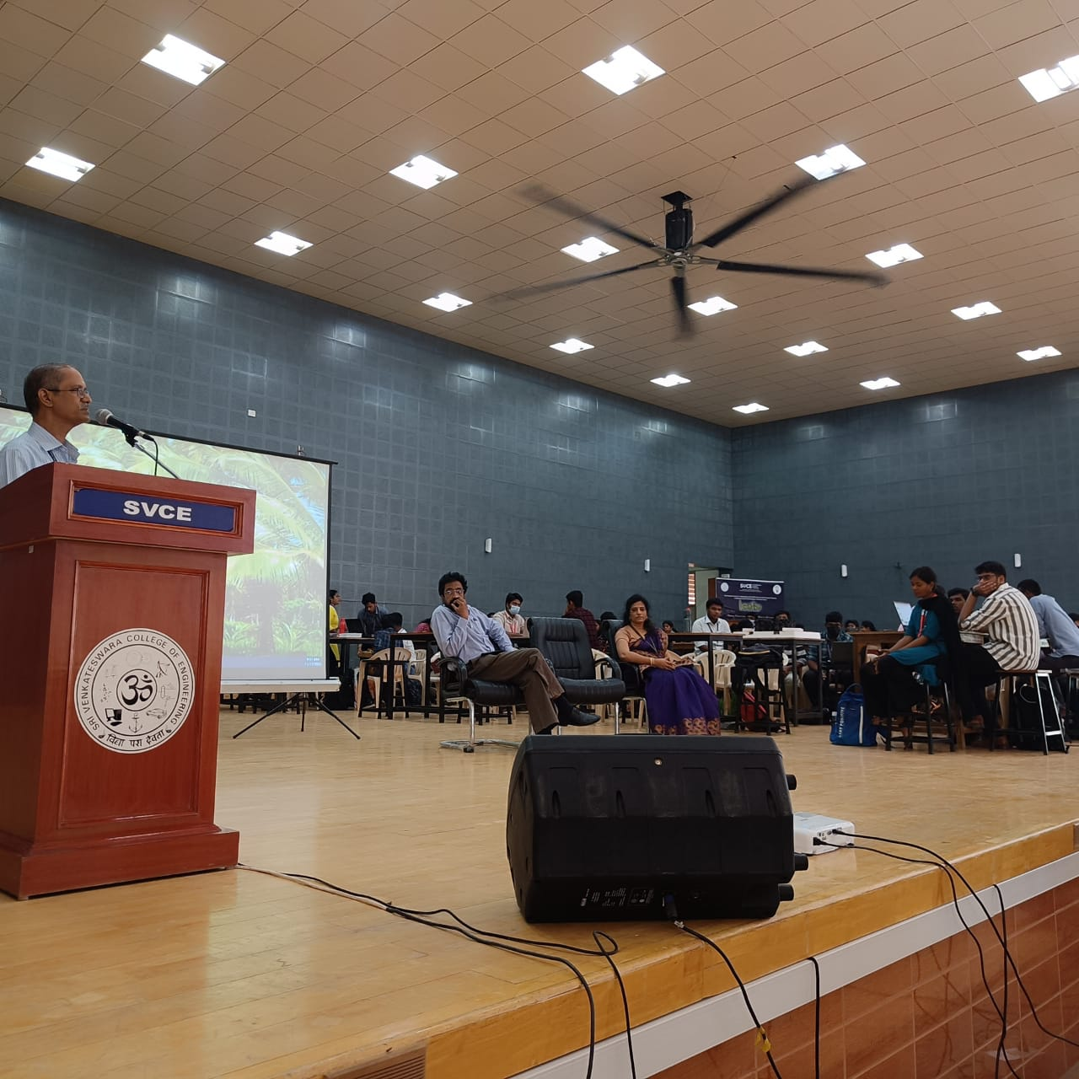

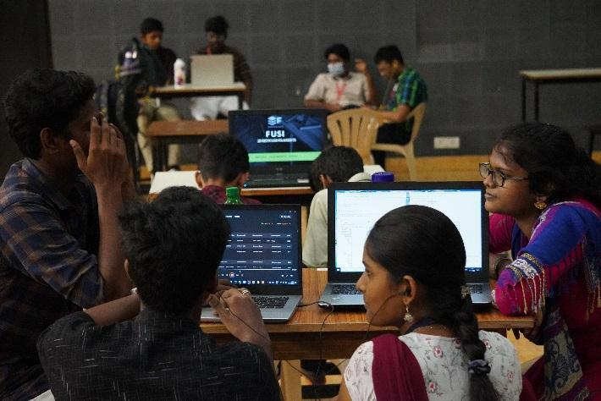

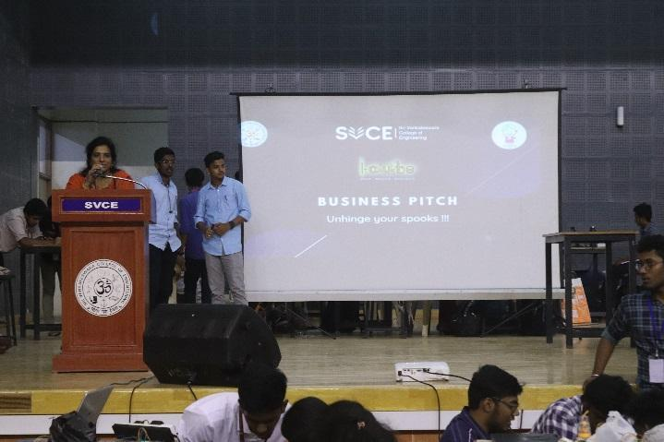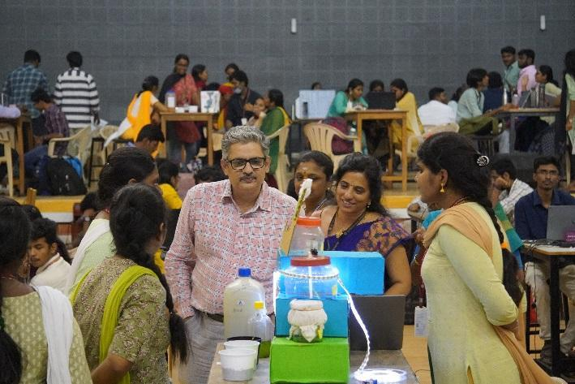

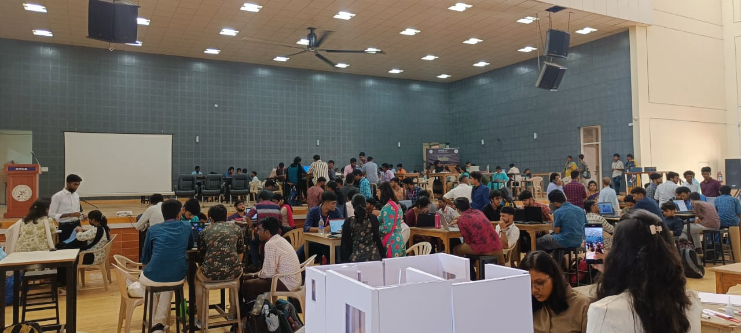

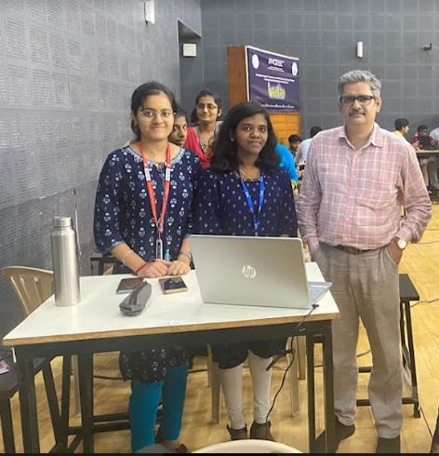

**TRACK 1 TRACK 2**

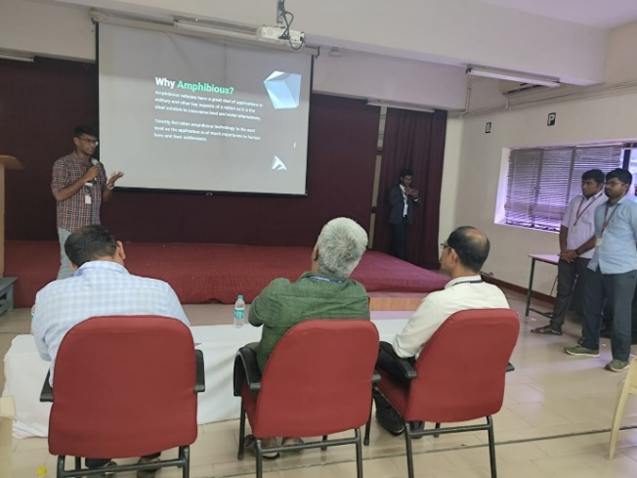 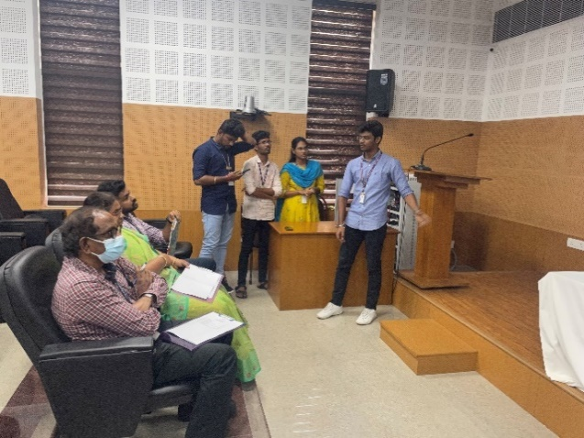

**TRACK 3 TRACK 4**

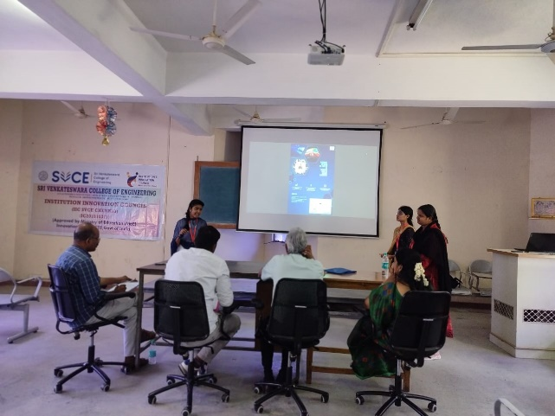 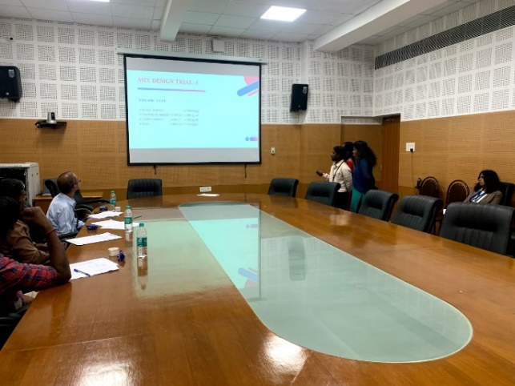

**TRACK 5**

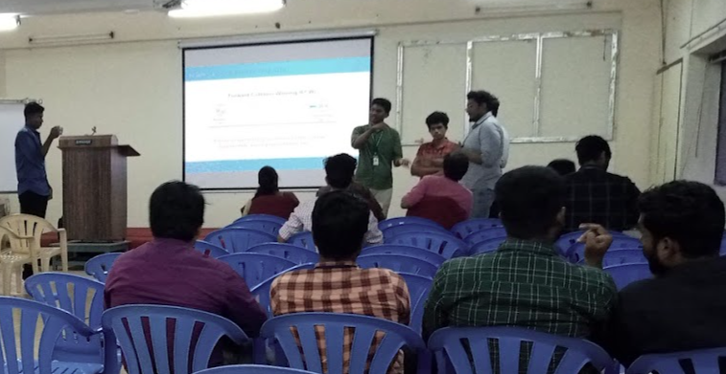

Prepared by

Organizing Team -i-CUBE

For

Dr.N.R.Sheela

(Coordinator SVCE Science Club)