Submitted to the Principal
16th Dec 2022

VALEDICTORY AND AWARD CEREMONY
Second Edition of i-CUBE -A National level Intercollegiate Technical Event

Date: 18th November, 2022
Day: Friday
Timing: 2:00 P.M to 3:15 P.M
Venue: Function Hall, SVCE

The Second edition of i-CUBE, a National level intercollegiate technical event organized by Students’ Council in association with SVCE Science Club . INNOWEL and IDEA-O-LITE are the transcendent events of the I-CUBE. Participants in INNOWEL will get problem statements and work on them in accordance with guidelines. In IDEA-O-LITE, the participants are given a theme “Sustainable Environment”, for which they should find a problem and bring the solution according to theme. The Phase II of the event was held on the 17th and 18th of November,2022, among 70 teams. The participants stayed here for two days and worked on their projects.

The valedictory function was held on 18th November 2022 at VIDEO Hall of SVCE between 2:00pm and 3:15pm. The event began with invocation. Mr.Venkatarangan Thirumalai, Software Entrepreneur, CEO Coach, Microsoft Regional Director(Honorary), and Dr.C Shanmugam, Managing Trustee, Centre for Science Promotion and Research (CSPR), Chennai were the chief guests for the valedictory and award ceremony, presided by Vice-Principal Dr.K.R.Santha, Professor and head department of EEE. Dean (Research) Dr.R.Muthucumaraswamy welcomed all the dignitaries present on the Dias and participants from various states, HoD’s, Deans and Students. Followed by the chief guests were felicitated by Dean (Students’ welfare) Dr.J.Venkatesan. The second edition of i-Cube report was presented by the Coordinator Dr.N.R.Sheela and thanked the management and Principal for providing all kind of facilities to conduct such mega technical event in the SVCE campus.The chief guests were received by Ms.Visalakshisubramanian, joint coordinator and introduced by former Students’ Council Secretary and Joint Secretary Mr.Maheeraj and Ms.Supraja.
The way Mr.Venkatarangan Thirumalai, delivered the talk earned a huge positive response and everyone was amused with his deep insights on the intercollaborative projects and suggested to apply patents for their prototypes. Mr.Shanmugham addressed the participants on subjective vs objective information and emphasized to know their implementation while making decisions.
After a rigorous evaluation process by both internal members include (Dr. R. Ramesh, Dean Academics, Dr. K. S - Badrinathan, Dean - Educational Development, Dr. J. Venkatesan, Dean - Students' Welfare, Dr.K.Pitchandi-Controller of Examination, Dr.R.Muthucumaraswamy-Dean Research) and external members include Mr.Mohammad Hussain, co-founder @ ALIEN, Mr.Kavin, co-founder @ALIEN &Zoopit, Mr.Athul, CEO Diffusion coatech, MrAshok Kumar-Product Developer, and Mr.Rajamurugan-CEO,Kellyville Business Solutions Pvt.Ltd for Business Pitch.The Winners and Runners of the Second Edition of iCUBE were announced during the ceremony. Based on the evaluation, the team named, Ingenious from Sri Venkateswara College of Engineering was awarded Winners of Idea-O-Lite, and the team Fresh Spar Technologies from Sri Krishna College of Engineering, Coimbatore, was awarded as the Runners of Idea-O-Lite. The team Espresso a.a.a from Sri Venkateswara College of Engineering was awarded as the winner of INNOWEL and the team Mech Mavericks from SSN was awarded as the Runners of INNOWEL. The Chief guests and dignitaries awarded the Winners and Runners from INNOWEL and IDEA-O-LITE each were given cash prizes of Rs.25,000 (for winners) and Rs.10,000 (for runners). Dean(Research) felicitate the external pannel members Mr.Mohammad Hussain, co-founder @ ALIEN, Mr.Kavin, co-founder @ALIEN &Zoopit, Mr.Athul, CEO Diffusion coatech, and Mr.Rajamurugan-CEO,Kellyville Business Solutions Pvt.Ltd for Business Pitch.
After the prize and certificates distribution, the ceremony concluded with a Vote of Thanks delivered by Mr. Nitin Raj. Vice -President of SVCE Science Club.

VALEDICTORY FLYER

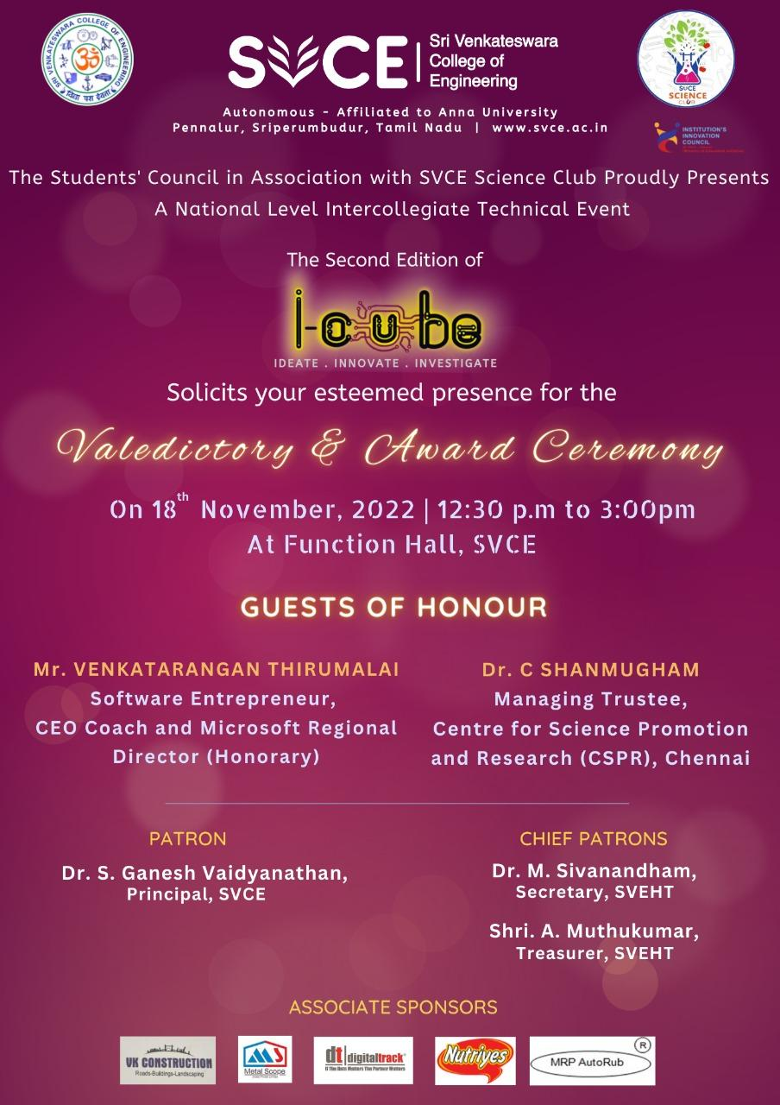

Winners and Runners Details

IDEA-O-LITE |  |  |  |  | WINNERS  Sri Venkateswara College of Engineering | Team Name: Ingenious  Project Title:Pollutionless Ultrasonic Horn | No. of Participants:03  1.Mr. Irfan Abdulla  IVth Year EEE  Mobile No:7200486500  2..Mr.A. Ramanathan  IVth Year MEC  Mobile N0:7092763895  3.Mr.Ashiq Mohamed Illahi  IVth Year EEE  Mobile No:9626992346
IDEA-O-LITE |  |  |  |  | RUNNERS  Sri Krishna College of Engineering -Coimbatore | Team Name:-Fresh Spar Technologies  Project Title: PREGMED | No. of Participants:04  1.Manoj Kumar C  II Year B.Tech CSBS  Mobile No:8637469722  2.Krishna K  II Year B.Tech CSBS  Mobile No:8072551665  3.Sandhya Barathi K  II Year B.Tech CSBS  Mobile No :6381559549  4. Sri Subiksha T  II Year B.Tech CSBS  Mobile No :9345971978
INNOWEL |  |  |  |  | WINNERS  Sri Venkateswara  College of Engineering | Team Name: Espresso.A.A.A  Project Title: Smart Ticketing Systems for Buses | No. of Participants:03  1.Rajit. H  III Year ECE  Mobile No:9884445469  2.Srivani M  III Year ECE  Mobile No:7448810203  3.Sriram V  III Year INT  Mobile No:9025893621
INNOWEL |  |  |  |  | RUNNERS  Siva Subramania Nadar College of Engineering -Coimbatore | Team Name:  Mech Mavericks  Project Title:  Low Cost Ultrasonic Water Flowmeter | No. of Participants:02  1.E. Akileshwaran  III Year Mechanical  Mobile No:9445060542  2. N. Magesh Nachiappan  III Year Mechanical  Mobile No:9361316211

PHOTOS

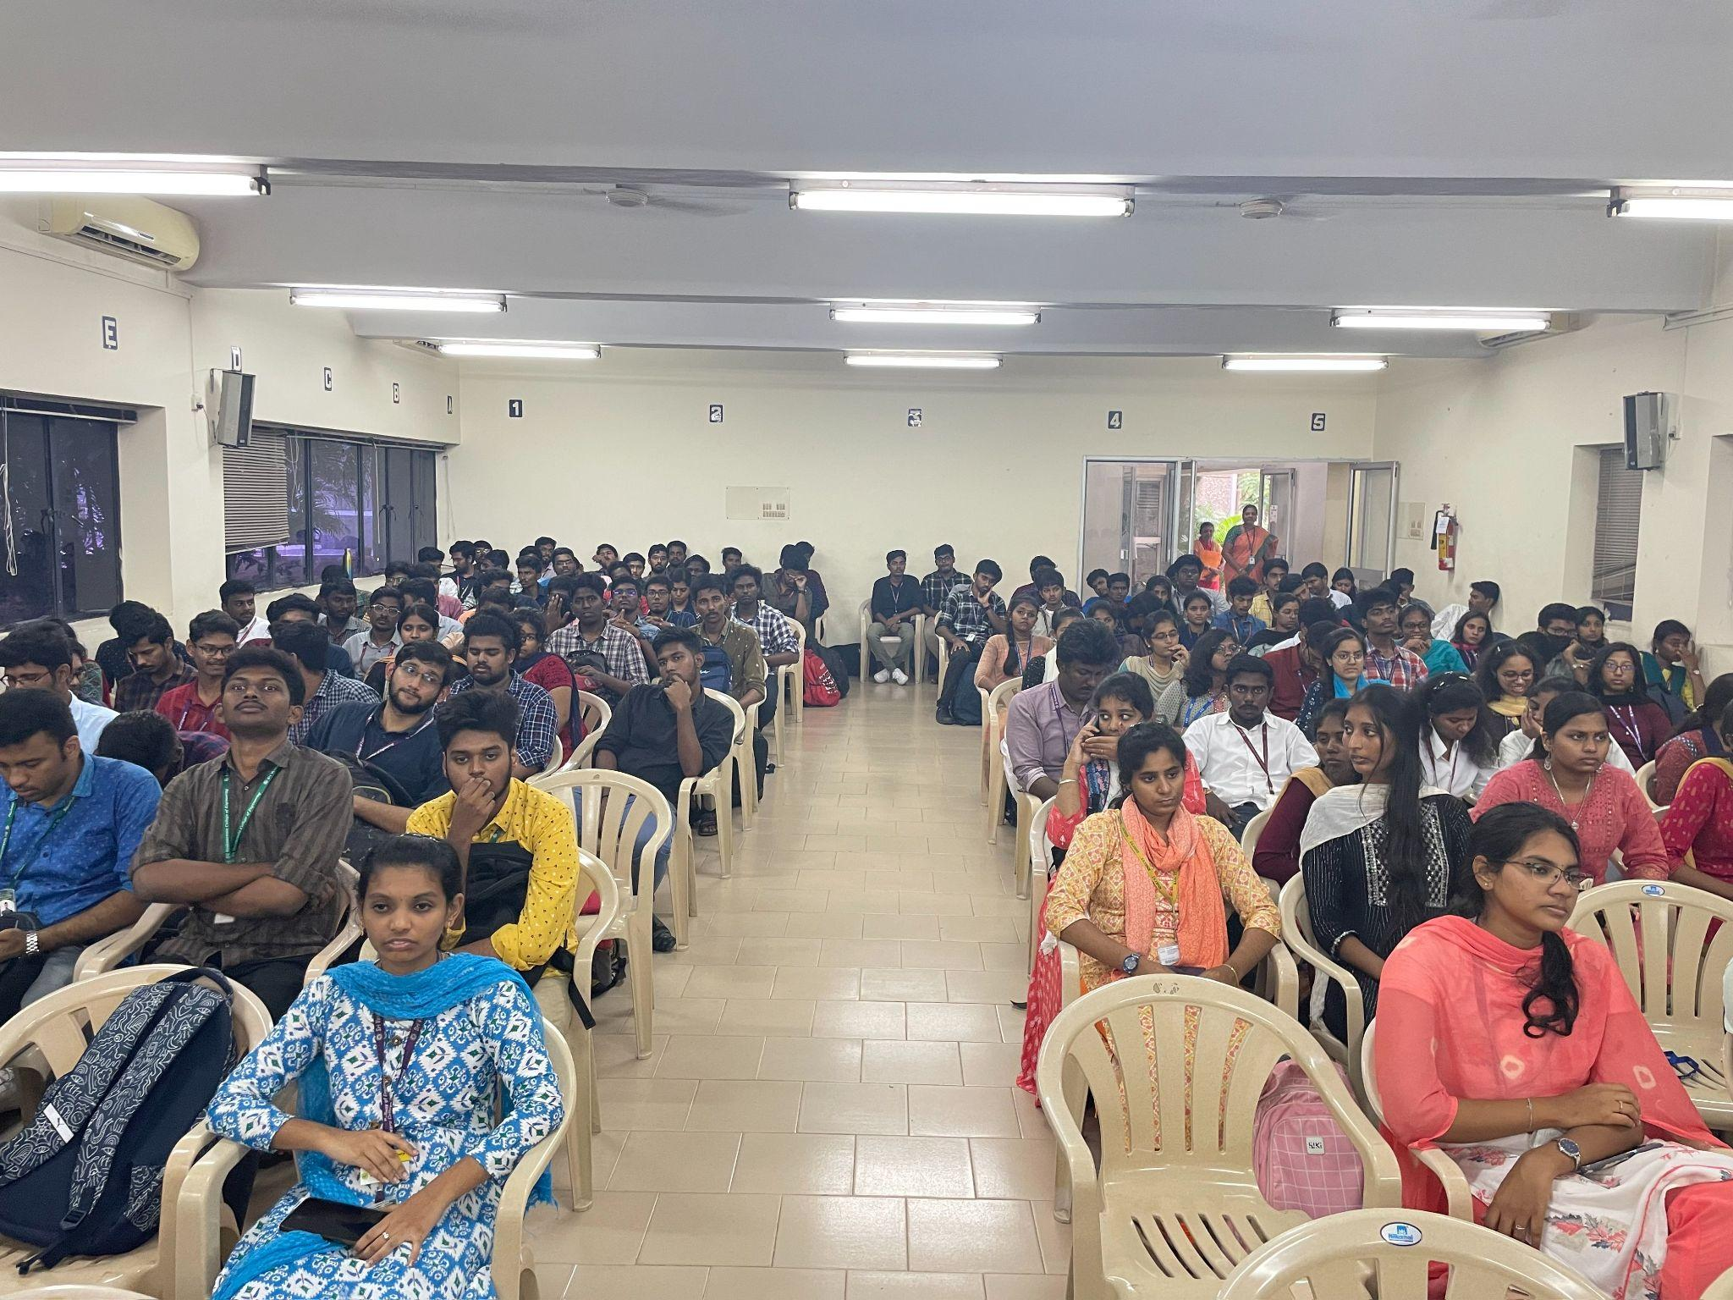
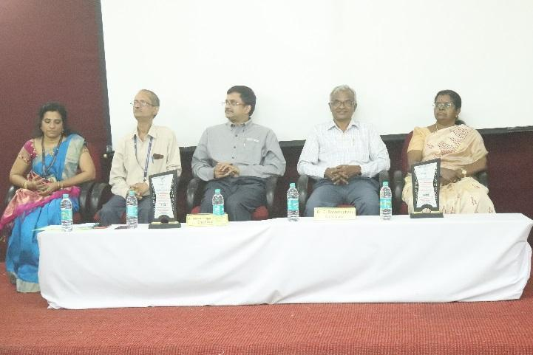

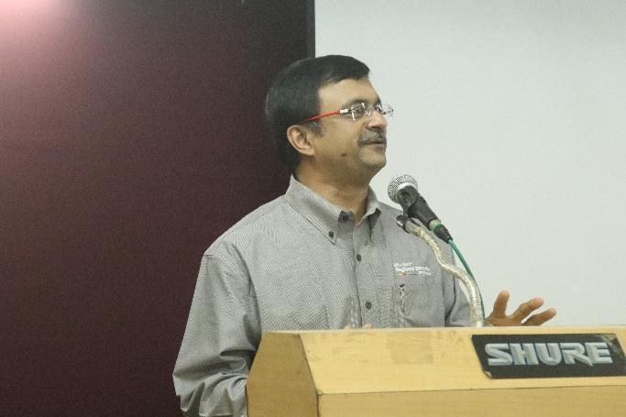
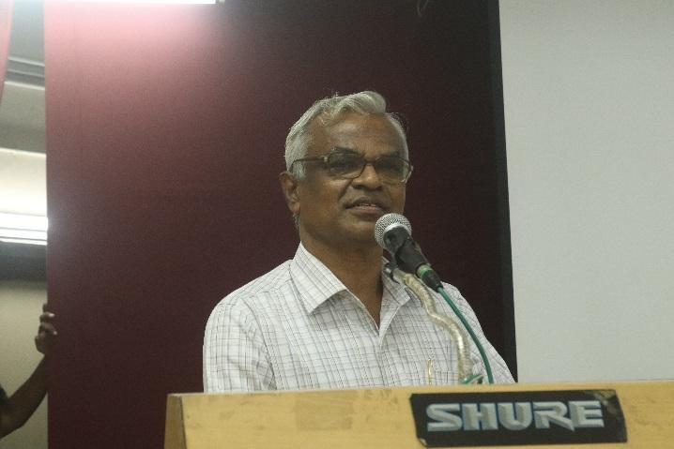

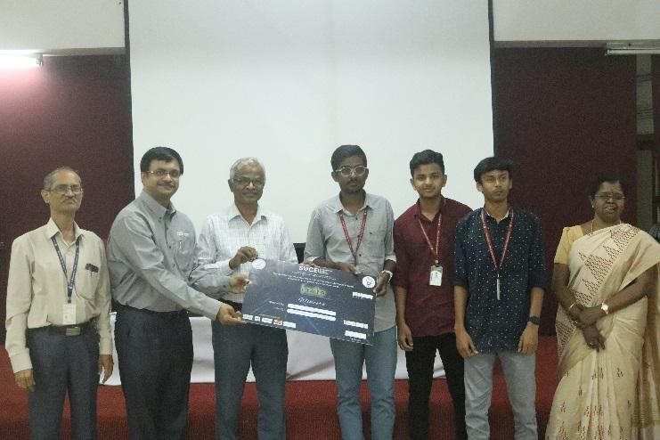
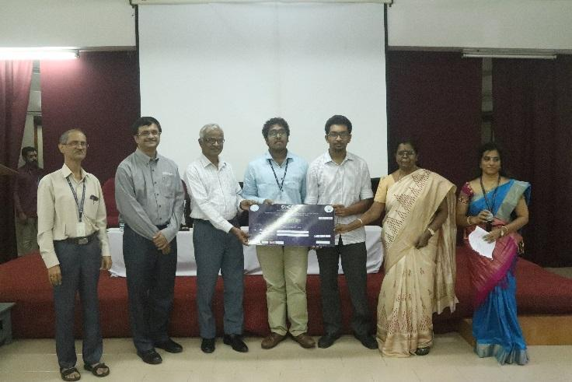

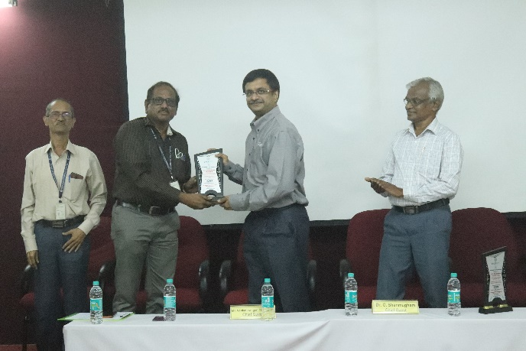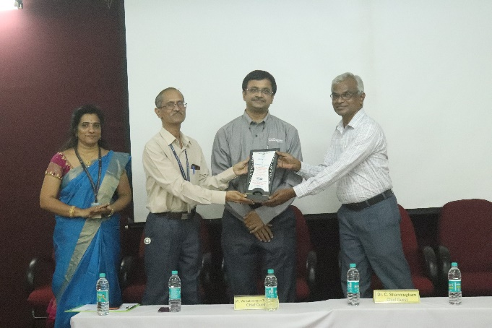

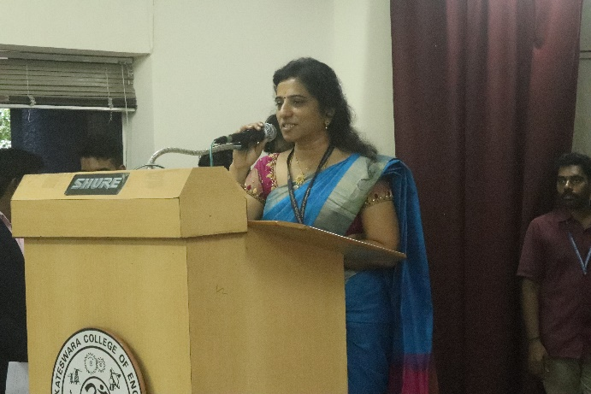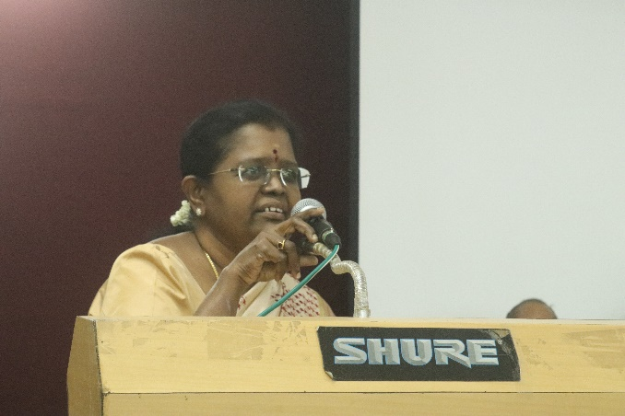

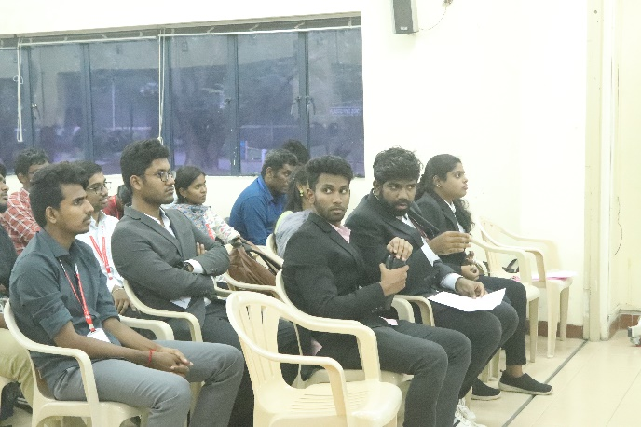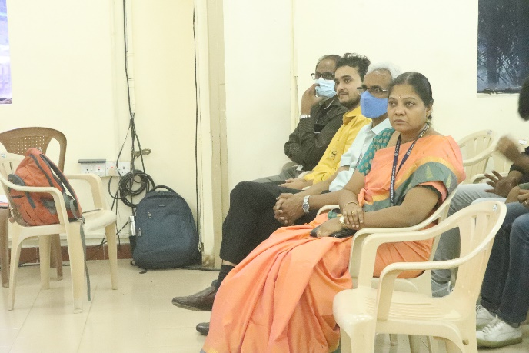

Prepared by
Organising Team i-CUBE
For
Dr.N.R.Sheela
Coordinator SVCE Science Club

