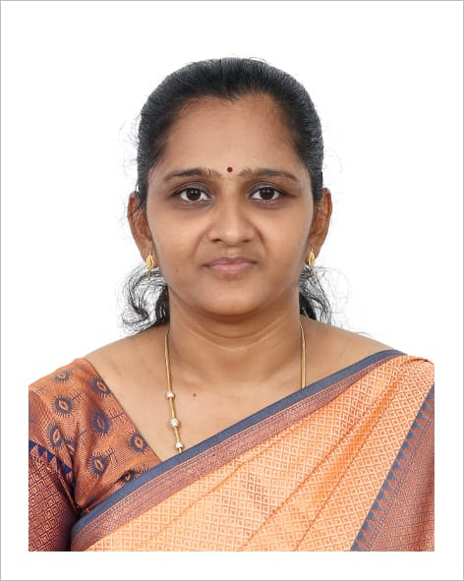 |  | Dr A Kala Associate Professor Department of Information Technology Sri Venkateswara College of Engineering, Sriperumbudur 602117. Email:akala@svce.ac.in Phone: 91 44 2715 2000 Ext. 360
Ph.D | Information and Communication Engineering |  | Anna University | 2022
M.E (CSE) | Sri Venkateswara College of Engineering |  | Anna University | 2013
Research |  |  | Recognized as a Research Supervisor by Anna University for guiding Ph.D. scholars (Supervisor No- 4140137)
Teaching Experience |  |  | 17 years

Research interests
Data Mining
Machine Learning
Deep Learning
Bio-Inspired Computing

