Dr G Sudha Associate Professor Department of Chemical Engineering email:sudha@svce.ac.in Phone: 91 44 2715 2000 Ext. 551
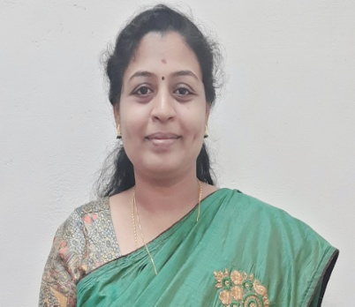

NAME OF DEGREE | UNIV / INST | YEAR OF PASSING | DIVISION
UG | Madras University | 2001 | Chemical Engineering
PG | National Institute of Technology (Trichy) | 2005 | Chemical Engineering
Ph.D. | Anna university | 2021 | Experimental and Simulation Studies on Hybrid Nanocoolant for Heat Transfer

Research interest
Key areas:
Heat Transfer studies in Microchannel Heat Sink
Synthesis of NanoMaterials
Radiative heat transfer
Thermal Management of Electronic systems

